Notification

In connection with the Notification no:102/2/2021-Estt/2141-45 dated 19/07/2022 the modified schedule of walk-in interview for the appointment of Guest Faculty, 7 nos (UR) in the Department of Agricultural Engineering is on 08th August 2022 at 1:30 PM.

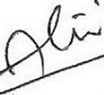 Date: 03/08/22
Head(i/c)
Dept of Agricultural Engg.
TSSOT, AUS

