Department of Chemistry

Assam University, Silchar

ADMISSION NOTICE (2ND DRIVE)

Applications are invited from eligible candidates belongs to OBC, SC & ST category for filling up few seats for admission into the PG Ist semester course in Chemistry for the year 2019-20. The details of the schedule of submission of application, date of written test and personal interview are given below.

1. Last date of submission of online applications : 07-09-2019 (upto 5.00pm)
2. Date of written test & personal interview : 09-09-2019 (from 11.30am)
3. Display of Selection list and admission : 10-09-2019

Applicants are required to bring all original documents at the time of personal interview.

Reservations of seats are as per Govt. of India rules in force.

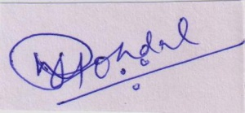

Prof. P. Mondal

HOD, Chemistry

Copy for information to:

1. Chairman, Central Admission Committee
2. Registrar, AUS
3. Director, Computer Centre – with a request to upload the notice and open admission portal
4. PS to VC – for kind information of the VC
5. O/



HOD, Chemistry