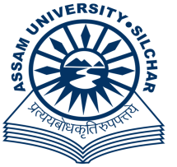

Department of Microbiology
Assam University
Silchar-788011, Assam

Advertisement
Applications are invited Walk-in-Interview for two positions of Studentship and two positions of Trainingship and training for DBT Project.
Name of the Project | Name of the Post | Essential Qualification | Scholarship
Impact of Rhizosphere Mediated Bioremediation of Polyaromatic Hydrocarbons on different soil microbiomes in Contaminated Surface Soil of Oil and Gas Drilling Sites in Assam. | Studentship | Students pursuing M.Sc in Microbiology/ Biotechnology /Life Science | Rs. 5,000/- per month
 | Trainingship | M.Sc in Microbiology/ Life Science/ Biotechnology/ Ecology/ Botany with minimum 55% marks. | Rs. 8,000/- per month (consolidated)

Interested applicants may walk-in for the interview with bio-data and supporting documents in original. No TA/DA will be paid for attending the interview.

Venue: Department of Microbiology.
Date & Time: 12th September 2019, 02:00 PM onwards.
Sd/-
Prof. Piyush Pandey
Professor and Head
Department of Microbiology
Assam University, Silchar-788011
(Email: piyushddn@gmail.com)

