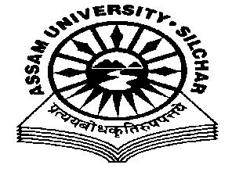
Department of Philosophy Assam University, Silchar.
The Meeting of the Departmental Affairs Committee, Department of Philosophy was held on 20th October, 2020 at 11.45 AM, at the Department
Members Present:
1.Dr. Pius V Thomas (Head I/C, In Chair) 2. Prof. A Nataraju, (Dean SRS of Philosophical Studies, Member) 3. Prof. Subhra Nag (Member) 4. Prof. Nirmali Barman (Member) 5. Dr. Munmun Chakraborty (Member)

Agenda
To assess the reports submitted by the Coordinators Prof. Nirmali Barman and Dr. Munmun Chakraborty on NAAC/IQAC suggestions on 1. Action taken on Advanced learners, 2. Poor Learners, 3. Departmental Mentors and 4. Departmental Counselors
Minutes
- Minutes of the last Meeting, which was held on13/08/2020, was read and confirmed
- The Meeting discussed and assessed the reports placed on table by A. Prof. Nirmali Barman, the Coordinator who deals with the Faculty Members acting as the Departmental Counselors and students feedback, and B. Dr. Munmun Chakraborty, the Coordinator who deals with 1. The action taken on advanced learners, 2. Poor Learners of the Department, 3. Faculty Members acting as Departmental Mentors in advising the students on academic matters based on NAAC/IQAC suggestions. The Meeting approved the reports submitted by the Coordinators with minor modifications.

The Meeting ended with thanks to and from the Chair.

Pius V Thomas Head I/C Department of Philosophy .

