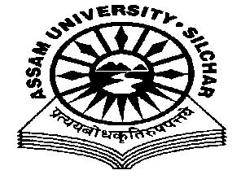
Department of Philosophy Assam University, Silchar.

The Meeting of the Departmental Affairs Committee, Department of Philosophy was held on 17th November, 2020 at 11.45 AM, at the Department
Members Present:
- Dr. Pius V Thomas (Head I/C, In Chair)
- Prof. A Nataraju, (Dean SRS of Philosophical Studies, Member)
- Prof. Subhra Nag (Member)
- Prof. Nirmali Barman (Member)
- Dr. Munmun Chakraborty (Member)

Agenda
IQAC suggestion to introduce internship for the MA Philosophy Programme
Minutes
- Minutes of the last Meeting, which was held on 20/10/2020, was read and confirmed
- The Meeting discussed the report submitted by Prof. Subhra Nag, the Coordinator on arranging the internship project for the MA Philosophy Programme, which initiated the internship project involving 1. A Media House 2. UG/PG Level Colleges and 3. NGO organizations who are involved in serious research and academic activities, and approved it.

The Meeting ended with thanks to and from the Chair.

Pius V Thomas Head I/C Department of Philosophy

