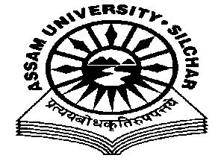
Department of Philosophy Assam University, Silchar.
The Meeting of the Departmental Affairs Committee, Department of Philosophy was held on 1/3/2021 at 11.45 AM, at the Department
Members Present:
1.Dr. Pius V Thomas (Head I/C, In Chair) 2. Prof. A Nataraju, (Dean SRS of Philosophical Studies, Member) 3. Prof. Subhra Nag (Member) 4. Prof. Nirmali Barman (Member) 5. Dr. Munmun Chakraborty (Member)

Agenda
- Matters related to the Appointment of Micro-site Administrator and Research Coordinator of the Department .
- Matters related to the maintenance of the WiFi Internet Connectivity
- Matters related to the preparedness for NAAC Visit
Minutes
- Minutes of the last Meeting, which was held on 19th January, 2021 was read and confirmed
- The Meeting endorsed Dr. Munmun Chakraborty as the Micro-site Administrator and Research Coordinator of the Department .
- The Meeting discussed the issues related with maintenance of the WiFi Internet Connectivity and UPS and entrusted the Head to write to the Computer Centre.
- The Meeting also discussed the immediate the preparedness for NAAC Visit and entrusted the Head to write to the VC for a financial aid.

The Meeting ended with thanks to and from the Chair.

Pius V Thomas Head I/C Department of Philosophy .

