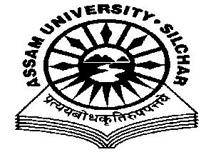
Department of Philosophy Assam University, Silchar.
The Meeting of the Departmental Affairs Committee, Department of Philosophy was held on 19th January, 2021 at 11.45 AM, at the Department
Members Present:
1.Dr. Pius V Thomas (Head I/C, In Chair) 2. Prof. A Nataraju, (Dean SRS of Philosophical Studies, Member) 3. Prof. Subhra Nag (Member) 4. Prof. Nirmali Barman (Member) 5. Dr. Munmun Chakraborty (Member)

Agenda
- Matters related to PG Admission, Second Drive, Admission Committee Approval Etc.
- Induction Programme for the 1st Semester MA Philosophy Students
- Alumni Association meeting
Minutes
- Minutes of the last Meeting, which was held on 22/12/2020, was read and confirmed
- The Meeting discussed the PG Admission committee’s approval of the second drive of the PG Admission and the merit list prepared and endorsed it.
- The Meeting decided to conduct the Induction Programme online for the1st Semester MA Philosophy Students and approved the date for the programme as 25th January, 2021
- The Meeting discussed the proposal to conduct an online Alumni Association, Department of Philosophy, meeting on 22nd January, 2021 and entrusted the matter with Dr. Munmun Chakraborty, Coordinator, Alumni Association, Dept. of Philosophy, AUS

The Meeting ended with thanks to and from the Chair.

Pius V Thomas Head I/C Department of Philosophy .

