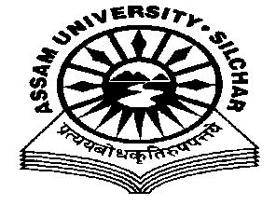
Department of Philosophy Assam University, Silchar.
The Meeting of the Departmental Affairs Committee, Department of Philosophy was held on 22/12/2020 at 11.45 AM, at the Department
Members Present:
1.Dr. Pius V Thomas (Head I/C, In Chair) 2. Prof. A Nataraju, (Dean SRS of Philosophical Studies, Member) 3. Prof. Subhra Nag (Member) 4. Prof. Nirmali Barman (Member) 5. Dr. Munmun Chakraborty (Member)

Agenda
Students Evaluation Feedback on line Teaching, Prepared by IQAC
Minutes
- Minutes of the last Meeting, which was held on 25/11/2020, was read and confirmed
- The meeting discussed the single agenda of the Students’ feedback on online teaching, prepared and compiled by IQAC. The meeting is of the opinion that that the feedback on online teaching categories such as ‘ability, coverage, uniformity, clarity, interaction, material, online evaluation, comparison’ were found fairly satisfactory and in most of the cases appreciable. However, the category of ‘network’ was found relatively wanting and needs more stability, which the meeting opined that was a regional and University level infrastructural issue.

The Meeting ended with thanks to and from the Chair.

Pius V Thomas Head I/C Department of Philosophy.

