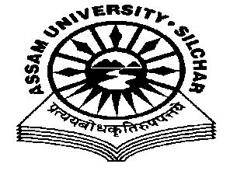
Department of Philosophy Assam University, Silchar.
The Meeting of the Departmental Affairs Committee, Department of Philosophy was held on 25th November, 2020 at 11.45 AM, at the Department
Members Present:
1.Dr. Pius V Thomas (Head I/C, In Chair) 2. Prof. A Nataraju, (Dean SRS of Philosophical Studies, Member) 3. Prof. Subhra Nag (Member) 4. Prof. Nirmali Barman (Member) 5. Dr. Munmun Chakraborty (Member)

Agenda
PG and M Phil-PhD Syllabus revision and modification
Minutes
- Minutes of the last Meeting, which was held on 17/11/2020, was read and confirmed
The Meeting discussed the PG and M Phil-PhD Syllabus revision and modification which was placed on table and requested the Head to coordinate it. The Meeting also decided to sent the revised syllabus to experts for review and comments.

The Meeting ended with thanks to and from the Chair.

Pius V Thomas Head I/C Department of Philosophy

