Social Work Department - Online document verification of the selected candidates for the admission of Ph.D. course
All the candidates provisionally selected for Ph.D. Course (2020) in Social Work Department are directed to submit the Pdf file of the self attested copies of all the mark sheets and certificates and SC/ST/OBC (Non Creamy Layer Certificate) in the Google Classroom by 25.08.2020.
Alternatively, they can email the documents to socialworkhodaus@gmail.com
On successful verification, you will receive the fee payment link for taking admission on or before 26.08.2020.

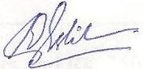
Prof. M Gangabhushan
Head
Dept of Social Work
Assam University, Silchar
9401020601
24/08/2020

