Faculty Profile
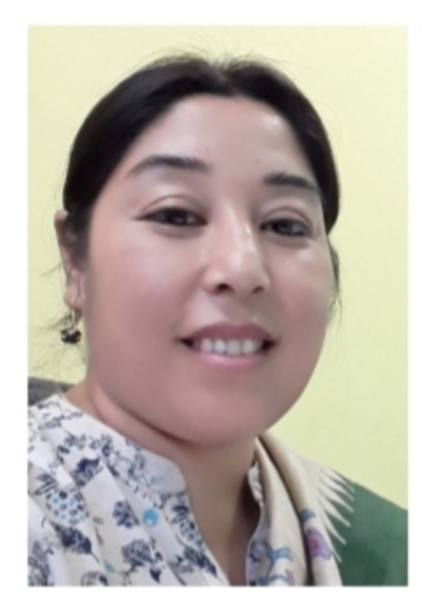

Name: Dr. M. Tineshowri Devi
Designation: Professor
Department/Centre: Social Work
Phone Numbers: 03842-280281(O)
9435172776 (M)
Email id: moirangi@yahoo.com
Educational Qualifications: MA in Social Work, Tata Institute of Social Sciences, Mumbai (2002); MPhil in Social Medicine and Community Health, Jawaharlal Nehru University, New Delhi (2004); PhD in Social Work, Assam University (2009).
Areas of Interest: Health and development, Gender, Youth and Elderly
Work Experience: [In chronological order with the recent one at the last.]
Name of the Organization | Designation | Period |  | Nature of Post  (permanent/temporary/Ad-hoc/ contractual etc.)
 |  | From | To
Delhi School of Social Work, Delhi University | Lecturer | July 2004 | September 2004 | Temporary
Department of Social Work, Assam University | Assistant Professor | October 2004 | August 2013 | Permanent
Department of Social Work, Assam University | Associate Professor | August 2013 | July 2016 | Permanent
Department of Social Work, Assam University | Professor | August 2016 | Till date | Permanent

Project Title | Awarding Agency | Ongoing/ Completed
“Impact Evaluation of ISWE being implemented in North Eastern States of India” | The Central Social Welfare Board, New Delhi | Completed

Publications in Peer Reviewed Journals/Book Chapters (Maximum 5)
Author | Title of the Paper/Chapter | Name of the Journal/Book | Journal/Book details | ISSN/ISBN
M. Tineshowri Devi | Psycho-Social Problems of Elderly | Centre for Study of social Exclusion and Inclusive policy, Manipur University. | Working Paper, Vol. 21, April, 1-24, | ISSN: 2393-879X
M. Tineshowri Devi | Elderly and Psycho-social Adjustment: A study in Manipur, India | Bangladesh Journal of Geriatrics | 53-54 (Joint Issue) October, p.32-50 | ISSN: 1012-9197
M. Tineshowri Devi | HIV/AIDS, Social Work and the Youth | Social Work Journal (Bi-Annual) | 8(1), 49-56 | ISSN: 0976-5484
M. Tineshowri Devi | The situation of the Elderly in Old Age Home-India and Bangladesh | Social Work Journal (Bi-Annual) | 10(1), 96-116 | ISSN: 0976-5484
M. Tineshowri Devi | Integrated Scheme for Women Empowerment and Status of Women in North East states | In (Eds.), Shukhdeba Sharma Hanjabam, Hanjabam Ishworchandra Sharma, Sadam Hanjabam. Development Questions in North East India. | New Delhi: Ruby Press Co. | ISBN: 978-93-86934-00-0

Books Authored/Edited Books
Authors | Title of the Book | ISBN | Publisher Details | Authored/Edited
M. Tineshowri Devi (Single author) | Reproductive Health and Adolescent Girls, pg. 1-302 | 978-81-8370-344-4 | Akansha Publishing House, 2010 | Authored
M. Tineshowri Devi  (with Dr. Bijoy Das) | GO-NGOs Partnership and Response to HIV/AIDS | 978-81-8370-580-6 | Akansha Publishing House, 2020 | Authored
M. Tineshowri Devi (With Dr. Bijoy Das and Amit Das) | Contemporary Issues of Northeast and Social Work Interventions | 978-81-8370-579-0 | Akansha Publishing House, 2020 | Edited

Details of Ph.D degree awarded (Under the supervision of the faculty):07
Name of the Scholar | Title of the Thesis | Year of award | Remark (if any)
- Irom Shirly | Psycho-social Problems of Elderly: A Study of Imphal West District in Manipur | 2014 | Department of Social Work, Assam University. (Registration No. Ph.D/1365/10 dated 24.10.2010)
- Khagokpam Pramodini Devi | Psycho-Social Problems of Men who have Sex with Men (MSM)- A Study of Imphal East and Imphal West Districts of Manipur | 2016 | Department of Social Work, Assam University. (Registration No. Ph D/1638/11, dated 20.09.2011)
- Lalzo S Thangzom | A Study on HIV/AIDS Mitigation Policies, Programmes and Strategies in Manipur | 2016 | Department of Social Work, Assam University. (Registration No. Ph.D/2323/13 dated 10.09.2013)
- Sword Ronra Shimray | A study of Utlization of Health Care Services in Ukhrul District of Manipur | 2017 | Department of Social Work, Assam University. (Registration No. Ph.D/1952/12, Dt.25.09.12)
- Wandaia Syngkon | A study of Problems of Single mothers and their children in shilling city of Meghalaya | 2017 | Department of Social Work, Assam University.  (Regsitration No. PhD/1958/12, Dt.25/09/2012)
- Bijoy Das | A Study of GO-NGO partnership in prevention and control of HIV/AIDS in Barak Valley of Assam | 2018 | Department of Social Work, Assam University.  (Regsitration No. PhD/2324/13, Dt.10/09/2013)
- Onkholun Haokip | A Study of Problems and Prospects of Youth in Senapati District, Manipur | 2019 | Department of Social Work, Assam University.  (Regsitration No. PhD/2542/14, Dt.16/09/2014)

