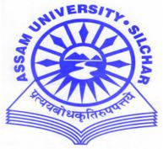
DEPARTMENT OF PHYSICS
ASSAM UNIVERSITY, DIPHU CAMPUS
(A Central University Established by an Act of Parliament)
DIPHU – 782462, KARBI ANGLONG, ASSAM.
Date 06-11-2022
NOTICE
This is for information of all concerned that the RET for admission into PhD programme- 2022 of Physics Department, Assam University, Diphu Campus shall be held in offline mode in the Department of Physics, Diphu Campus on 10th November, 2022 from 10-30 AM to 12-30 PM.
The candidates who qualify at the RET shall have the personal interview at 2PM onwards on 12th Nov., 2022 in which he/she shall make a presentation in the area of research interest before the Departmental Research Committee. At the time of PI candidates are required to produce all their testimonials in original for verification. In addition, they shall also submit a set of self attested photocopies of their testimonials, as and when required by the department.
The following candidates are selected to appear at the RET
Name Application number Mobile no
- Basanta Pathak 20231591 9678472099
- Rokteem Nath 20231532 8402080449
- Deivica Dkhar 20231486 7085922259

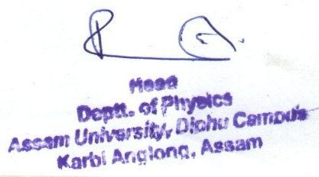

(Prof. Ranjit Singha)
HOD, Physics, AUDC

