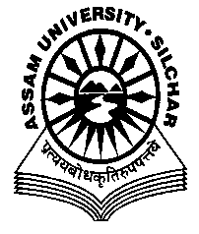

**ASSAM UNIVERSITY: SILCHAR**

**OFFICE OF THE DEAN**

**TRIGUNA SEN SCHOOL OF TECHNOLOGY**

**N O T I F I C A T I O N**

With reference to the earlier notification no. 134/AU-TSSOT/INTERNAL SLIDING/2015 dtd. 22nd October, 2022. It is hereby notified for information of all the students of various **B.Tech. (3rd year and final year) of session 2019-20 and 2020-21 and M.Tech courses of session (2020-21)** of the departments under TSSOT, that the **revised last date** to deposit the **Annual Fee for enrolment** in next academic year is extended upto **12th November, 2022,** through SBI collect link (<https://www.onlinesbi.com/sbicollect/icollecthome.htm?corpID=4870983>).

Further, for the students of **B.Tech. and M.Tech. courses of session 2021-22** of the departments under TSSOT, the details of Annual Fee payment will be notified once their end semester result will be published. For any assistance, students may contact office of their respective department.

* Note: The excess amount of Rs. 1000/- will be refunded/adjusted after the completion admission process.

**Prof. C. R. Bhattacharjee**

Dean(i/c)

Triguna Sen School of Technology

Assam University, Silchar

**MEMO NO : 134/AU-TSSOT/INTERNAL SLIDING/2015 Dated the 7th November, 2022.**

Copy to :

1. Heads of the Department, TSSOT for information and necessary action please.
2. Notice Board of the concerned department.
3. Office file.



**Prof. C. R. Bhattacharjee**

Dean(i/c)

Triguna Sen School of Technology

Assam University, Silchar