Word Formation in Assamese

A dissertation submitted to the Department of Linguistics, Assam University, Silchar
as a part of academic requirements for the fulfilment of Master of Arts Degree in
Linguistics
From
Assam University
2020



Roll: 042018 No.: 2083100007
Registration No: 20180016661

Department of Linguistics
Rabindranath Tagore School of Indian Languages and Cultural Studies
Assam University, Silchar
India-788011
Year of Submission: 2020
Department of Linguistics
Rabindranath Tagore School of Indian Languages and Cultural Studies
Assam University, Silchar(A central University Established by an act of Parliament)

CERTIFICATE

Certified that the dissertation project entitled Word Formation in Assamese is submitted by Roll: 042018 No.: 2083100007; Registration No: 20180016661 as a part of academic requirements for the fulfilment of Master in Arts Degree in Linguistics. This work has not been submitted previously by anyone for fulfilling the requirements of Master of Arts Degree in Linguistics in Assam University, Silchar. It is further certified that the candidate has compiled with all the formalities as per the requirements of Assam University. I recommend that the dissertation may be placed before examiners for consideration of award of the Degree from this University.

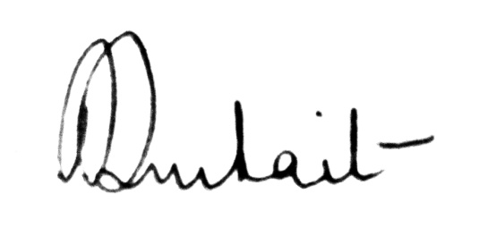5.10.2020
Name & Signature of Supervisor
(Signature)
Dr. Paramita Purkait
Assistant Professor
Department of Linguistics
Assam University, Silchar
DECLARATION

I, JugalakshmiGogoi, bearing Roll: 042018 No.: 2083100007 and Registration No: 20180016661 hereby declare that the content of the dissertation entitled Word Formation in Assamese is a genuine and the result of my own work. The content of this work has not been submitted in part or whole, to any institution, including this University, for any Degree or Diploma.
This dissertation is being submitted to the Department of Linguistics, Assam University as a part of academic requirements for the fulfilment of Master in Arts Degree in Linguistics.

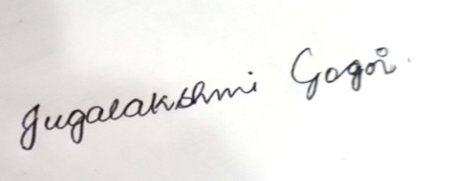

Date: 05/10/2020
Place: Silchar, Assam University Candidate: JugalakshmiGogoi
ACKNOWLEDGEMENT

I hereby offer my express my sincere gratitude towards Assam university for providing a course on Linguistics and giving me the chance to write a dissertation. I offer my earnest gratitude to my supervisor Dr. Paramita Purkait, Assistant Professor, Department of Linguistics, Assam University, Silchar for giving me the opportunity to undertake this research work under her supervision, and for her all the support, encouragement, patience, constant guidance, valuable suggestions, feedback and cooperation, without which this dissertation would not have been possible.
I am also thankful to all the other faculty of the department for their constant guidance and valuable suggestions. I would also like to thank my friends for their cooperation with me all the time, while I was collecting data and conducting the field work.
I am also grateful to my parents and family for their unfailing and unconditional support and constant encouragement.
Besides, my special thanks to all my classmates for all the help they provided through discussion and cooperation. I am also thankful to my seniors RajlaxmiKonwar and Nishi Gogoi for the help and guidance which they provided me. I offer my sincere thanks to the Librarian, Central Library of Assam University, Silchar.

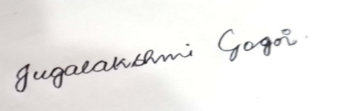

Date: 5.10.2020 JugalakshmiGogoi
MA in Linguistics
4th Semester
Assam University, Silchar

ABBREVIATIONS

3 : 3rd person
agen : Agentive
cl : Classifier
hon : Honorific
m : Masculine
pl : Plural
posp : Postposition
sg : Singular

List of Maps

Map No. Page No.
- Map 1: Map of Assam (source: www.mapsofindia.com) 3

List of Figures

Figure No. Page No.
1. Figure 1: Descent of the Assamese Language 2
2. Figure 2: The Assamese Vowel Quadrilateral 6

List of Tables

Table No. Page No.
1. Table 1: Consonants of Assamese 5
2. Table 2: Inflection Vs. Derivation 19
3. Table 3: Class-maintaining Affixes 20
4. Table 4: Causative verb formation using -ua- morpheme 21
5. Table 5: Causative verb formation using -ija- morpheme 21
6. Table 6: Causative verb formation using -oa- morpheme 21
7. Table 7: Suffixation with nouns 23

CONTENTS

Certificate i
Declaration ii
Acknowledgement iii
Abbreviations iv
List of Maps v
List of Figures vi
List of Tables vii
CONTENTS viii-x
Chapter 1: The Assamese Language and Community 1-11
1.0. Introduction 1
1.1. The Assamese Language 1
1.1.1. Geography and Population 1
1.2. Dialects of Assamese 3
1.3. Typological Features 4
1.4. Phonemic inventory of Assamese 5
1.5. Society and Culture 6
1.5.1. Festivals of Assam 7
1.5.2. Social Ceremonies and Food Items 8
1.5.2.1. Social Ceremonies 8
1.5.2.2. Food Items 8
1.5.3. Traditional Dance Forms of Assam 10
1.5.4. Dress and Ornaments 11
1.5.5. Religion 11
1.6. Topic of the study 11
Chapter 2: Review of Literature 12-13
Chapter 3: Objectives and Methodology 14-15
3.1. Objectives of the study 14
3.2. Data 14
3.2.1. Primary data 14
3.2.2. Secondary data 15
Chapter 4: Word Formation in Assamese 16-30
4.1. Word Formation: An Overview 16
4.1.1. Types of Word Formation processes 17
4.2. Word Formation Processes in Assamese 17
4.2.1. Inflection and derivation 18
4.2.1.1. Class-maintaining 19
4.2.1.2. Class-changing 20
4.2.2. Affixation 21
4.2.2.1. Prefixation 22
4.2.2.2. Suffixation 22
4.2.2.3. Pratyaya 24
4.2.3.4. Vibhaktis 24
4.2.3. Reduplication 25
4.2.4. Compounding 26
4.2.4.1. Endocentric Compounds 26
4.2.4.2. Exocentric Compounds 27
4.2.5. Back-formation 27
4.2.6. Blending 28
4.2.7. Clipping 28
4.2.8. Loanwords 28
4.2.9. Calque or Loan Translation 29
4.2.10. Coinage 29
4.2.11. Abbreviation or Acronym 29
4.2.12. Eponym 30
4.3. Loanwords in Assamese 30
Chapter 5: Conclusion 31
Bibliography 32

Chapter 1
The Assamese Language and Community
1.0. Introduction
Assamese is the anglicized name for /ɔɦɔmija/ which is one of the major languages spoken in Northeast India beyond West Bengal. It is the major language of Assam and is recognized by the 8th schedule of the Indian constitution as per the articles 344(1) and 351. Assam, pronounced as /ɔɦɔm/ by the native speakers and hence the word /ɔɦɔmija/ has been derived from the word /ɔɦɔm/ and the adjectival suffix -ijawhich means ‘of’, ‘relating to’ or ‘belonging to’. The Assamese people are the indigenous people of the state of Assam. This sub-group is often associated with Assamese language or any other tribal dialect of Assam. They are a physically diverse group from after years of assimilation of Austro-Asiatic, Indo-Aryan, and Tibeto-Burman races. The people belonging to Assam along with belonging to an indigenous community of Assam and speaking the Assamese language or any tribal dialect of Assam as his/her first language are referred as the Assamese people.
This chapter discusses about the Assamese Language: its geography and population, its dialects, typological features, phonemic inventory and also about the Assamese society and culture.
1.1. The Assamese Language
1.1.1. Geography and Population
The North Eastern part of India comprises the seven sister states of Assam, Meghalaya, Manipur, Nagaland, Tripura, Mizoram, and Arunachal Pradesh. It is a veritable Tower of Babel which, according to the census report of 1971, has a total of 220 languages. The languages present here belong mainly to five language families, namely Indo Aryan, Sino-Tibetan, Tai-Kadai, Dravidian (spoken by the tea garden communities) and Austro-Asiatic. The Indo-Aryan is represented mainly by /ɔɦɔmija/ and Bangla, Austro-Asiatic by Khasi and the Sino-Tibetan family of languages is represented by the Tibeto-Burman and the Siamese-Chinese sub families. The languages of a sizeable population of the tea tribes speak dialects belonging to the Dravidian languages of South India. There are also a few Tai languages like Tai-Khamyang, Tai-Khamti, Tai-Aiton, Tai-Phake and Tai-Turung. It is worthwhile to mention here that Tai-Ahom, a language belonging to this Tai group, has over the years merged with /ɔɦɔmija/. The following figure shows the descent of the Assamese language.
Figure 1: Descent of the Assamese Language
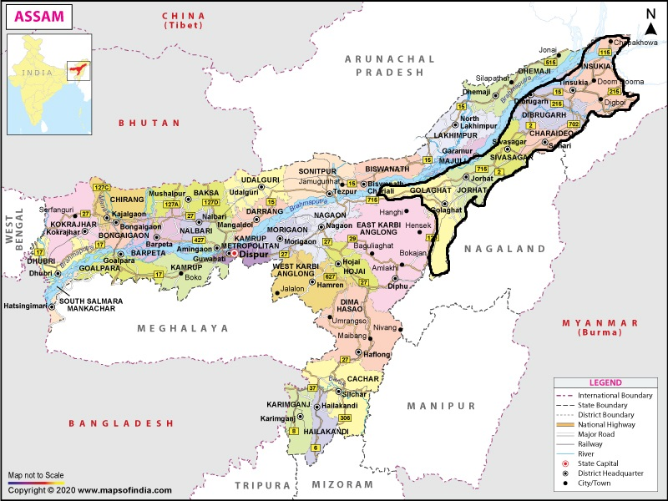
However, Assamese is the major language of Assam (excluding the Barak Valley where Bengali is the major language) and serves as the lingua franca among different speech communities of the entire region. It is recognized by the 8th schedule of the Indian constitution along with Bodo, Nepali and Bengali. It is spoken in the states of Assam, Arunachal Pradesh, Meghalaya and Nagaland. In Assam, it is spoken in the Brahmaputra valley districts from Lakhimpur in the east to Goalpara bordering Bangladesh and West Bengal in the west. In all the districts of Arunachal Pradesh, the people who live in the border areas to the plains also use it as a common language. As the Northeast is a land various ethnic cultures, so many people also use Assamese as a link language. In the state of Nagaland, a hybrid form of Assamese called Nagamese (a harmonious blend of Naga dialects and Assamese) is spoken. The Bhutanese people who are in a contiguous state with the people of Darrang, Kamrup and Goalpara speak Assamese for business and other purposes. The map in the below shows the state of Assam which in which the Assamese language or /ɔɦɔmija/ is spoken:

Map 1: Map of Assam (source: www.mapsofindia.com)
According to the population census of India 2011, out of the total population of 13,257,272 in Assam, the majority of 10,013,013 or 75.52% comprise of Hindus, and a minority of 2,830,072 or 21.34% consist of Muslims the remaining and the remaining 414,187 or 3.14% consist of Christians and Sikhs. My proposed work is based upon the Standard Assamese dialect of upper Assam which is mainly spoken in Golaghat, Jorhat, Sivasagar, Charaideo, Dibrugarh and Tinsukia.
1.2. Dialects of Assamese
Kakati (1941) has divided all the Assamese dialects into Eastern and Western Assamese. According to him the language from Sadiya to Guwahati constitute of a single homogenous entity and hardly differ from the language spoken in Sibasagar. Kakati names this dialect as the Eastern Assamese dialect and further states that for all the purposes of literature this dialect is used as the standard language. But Goswami (1982) states that there is a notable difference in the phonology and morphology within this eastern dialect and he further subdivides them to two groups: Eastern and Central dialects. Thus, the dialects of Assamese may be regrouped into Eastern, Western and Central or rather Intermediate Dialects. The following can be stated according to this regrouping:
- Eastern Assamese is spoken in the districts of Sibasagar and Lakhimpur down to the eastern half of the districts of Darrang and Nagaon in the west.
- Western Assamese covers a fairly big area from a little east of Guwahati in the South and western half of Darrang in the North, and down to Goalpara district in the west.
- Central or Intermediate Assamese occupies the area between the wo regions mentioned above, i.e. the whole area in the western half of the district of Nagaon, and extending a little east of Guwahati in the Kamrup district.
The Eastern and the Central dialects may be seen to be uniform to a certain extent in their respective areas while the Western Assamese is more heterogeneous in character with large variations in east, west, north and south. The two major dialects, the Eastern and Western Assamese differ in almost all areas like phonology, morphology, inflections, intonation and sometimes the speakers of either group find it very difficult to understand one another. The sub-dialects of Western Assamese differ mainly in phonology, intonation and sometimes vocabulary. The Central Assamese carries the features of both Eastern and Western Assamese.
At present the people of Assam broadly divide Assamese into two main dialects: The Upper Assam Assamese dialect which is also known as the Sivasagaria Variety and the Lower Assam Assamese dialect which is also known as the Kamrupia variety. However, as mentioned earlier, both the Eastern and Western Assamese differ in their sub-dialects, i.e. Eastern Assamese also varies from Tinsukia in the extreme east to Golaghat in the west whereas Western Assamese (as mentioned earlier) has various distinct features in the dialects of Barpeta, Kamrup, Nalbari and Goalpara which mainly include phonological and morphological features.
1.3. Typological Features
Crystal (1987) considers typology as the comparison of the formal similarities that exist between languages and an attempt to group languages into structural types, based on phonology, grammar, or vocabulary, rather than in terms of any real or assumed historical relationship. The classification of language in terms of those structural properties that are shared by virtue of common genetic origin or areal contact is known as the study of typology.
The typological features of Assamese are as follows:
- Word Order: Assamese follows SOV (subject-object-verb) word order, but scrambling is very common which at times leads to a change in meaning or puts emphasis on a particular fact.
- Head Final Language: Assamese is a head final language: a head final language is the one where the head is placed in the final position. For example, in a verb phrase in Assamese, the verb is placed in the final position. Similarly, in a noun phrase in Assamese, the noun is placed in the final position preceded by numerals, adjectives and so on.
- Classifiers: Assamese has an extensive classifier system and all the classifiers are suffixed to the noun.
- Gender: In Assamese, feminine gender is formed by suffixing the bound morpheme -i to a male root.
- Case system: Assamese follows a nominative-accusative case system with overt case marking. However, there is a debate amongst scholars as to whether the Assamese case system is nominative-accusative or Split-Ergative.
- Agreement in Assamese is suffixed to the verb and the structure is: verb root + aspectual/tense marker + agreement marker.
1.4. Phonemic Inventory of Assamese
There are 23 consonants and 8 oral vowels in Assamese. They are:
 | Bilabial | Alveolar | Palatal | Velar | Glottal
Plosive | p b  p^{h}b^{h} | t d  t^{h} d^{h} |  | k g  k^{h}g^{h}
Nasal | m | n |  | ŋ
Fricative |  | s z |  | x | h
Approximant |  | r | j | w
Lateral Approximant |  | l
Table 1: Consonants of Assamese

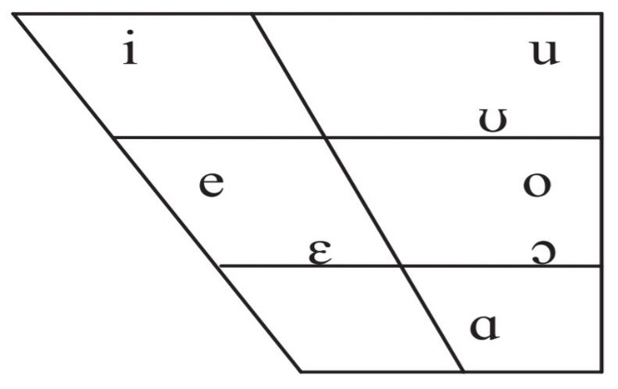
Assamese has 8 vowel sounds which are represented in the vowel quadrilateral below:

Figure 2: The Assamese Vowel Quadrilateral
1.5. Society and Culture
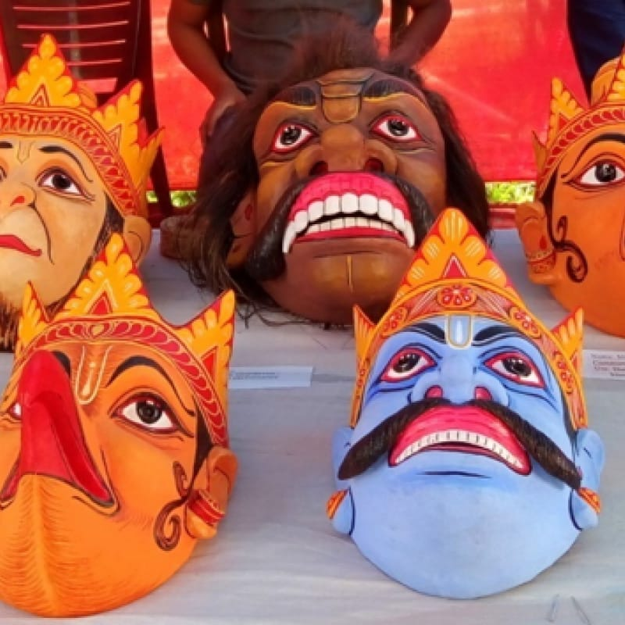
The culture of Assam is a hybrid one, developed due to cultural assimilation of different ethno-cultural groups and language families over the period of time. It is one of the most beautiful states of India and the gateway to the enchanting and unexplored North-eastern part of the country: with the mighty river Brahmaputra, the magnificent hills and its rich flora and fauna, the state is a paradise for tourists. The variant lifestyle, diversity of tribes and cultures makes the Assamese society a wonderful one. Assamese people are friendly, open and meek and are comprised of various tribes and communities and hence in this way they form the greater Assamese community.

Image 1: Mask culture of Majuli (Photo courtesy: www.india.com)
1.5.1. Festivals of Assam
Assam is a land of fair and festivals. Most of the festivals celebrated in Assam have their roots in the diverse faith and the belief of togetherness is the main characteristic of the celebration of all festivals celebrated in Assam. Bihu is the main festival of Assam.
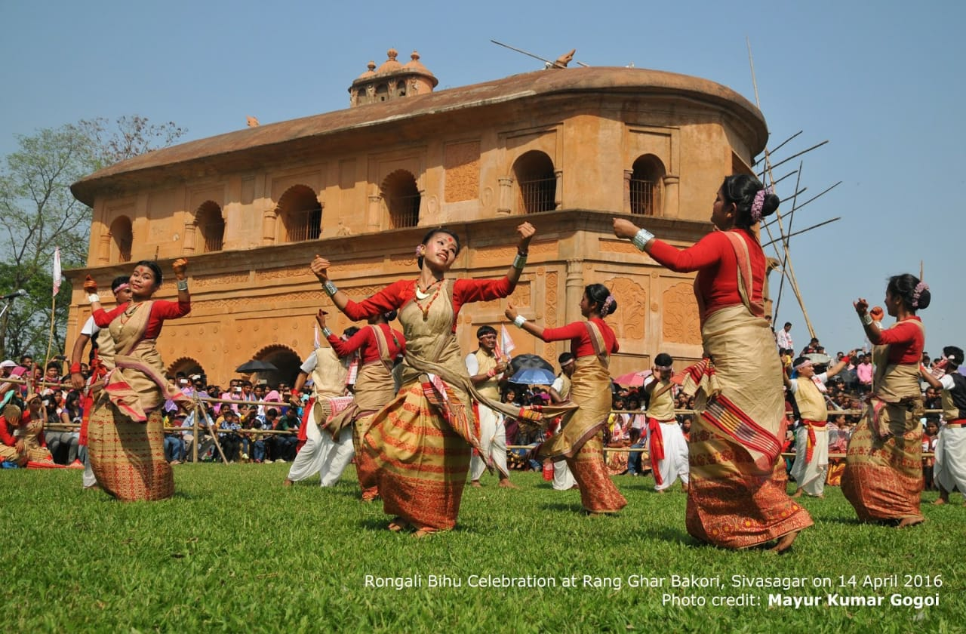
Marking the beginning of the agricultural session comes the most important festival of Bihu. It is celebrated three times a year: Rongali Bihu during mid-April with much pomp and grandeur which celebrates the coming of spring and the beginning of the sowing season; Kongali or Kati Bihu is the barren Bihu and is celebrated at a when the fields near the ripening season and the barns are empty, earthen lamps are lighted in the paddy fields; Bhogali Bihu or Magh Bihu can be said as the thanksgiving festival after harvest and there is surplus of food.

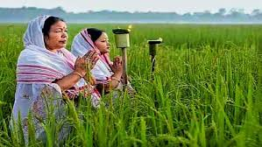
Image 2: Bohag Bihu (Photo courtesy: www.facebook.com)

Image 3: Kati Bihu (Photo courtesy: www.sentinelassam.com)
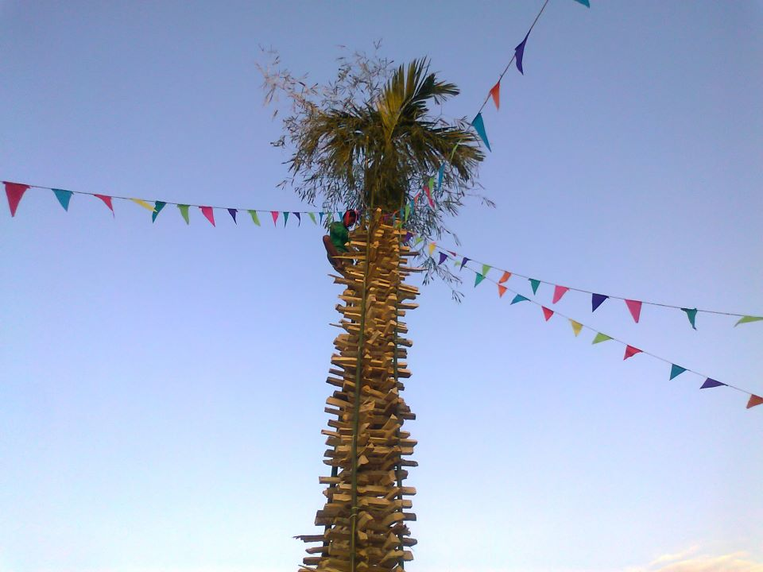

Image 4: Magh Bihu (Photo courtesy: www.indianholiday.com)
The other major socio-religious festivals include Durga Puja, Ali-ai Ligang (celebrated by the Mising community), Me-Dam-Me-Phi (celebrated by the Ahoms), Baishago, Jonbel mela, Id (Assam has a sizeable amount of Muslim population) and other tea community festivals, which show the heritage of the numerous races of Assam. These festivals are passionate, compelling and mesmerize the true spirit, tradition and lifestyle of the people of Assam.
1.5.2. Social Ceremonies and Food Items
1.5.2.1. Social Ceremonies
As stated earlier Assam is rich in cultural heritage and employs vivid customs and organizes various rituals. Wedding in Assam is of various types, the most notable ones being the Chok-Long (the Ahom practice, Image 5) and the normal Assamese wedding (Image 6). Moreover, various pujas (most notably Satyanarayan puja) and rituals organized during the birth or death of an individual make the social ceremonies of Assam diverse. People go to Namghars as and when the times comes and organize various social functions like bhaunas, xokam, naam and so on. All these practices come under the same umbrella with variations from place to place in Assam.
1.5.2.2. Food Items
Just like in any other place, the food of Assam is largely influenced by its climate, soil, and the nature of vegetation found in this place. The people of North-East India are mostly indulged in agriculture. Rice is the staple diet and most of the people of Assam have rice three times a day. Fish, chicken, duck and pigeon and pork are widely eaten and quite popular. Fish curry is another favourite which is prepared as a sour dish called MachorTenga. Baked fish wrapped in leaves with white mustard paste is a popular delicacy called Patotdiya mas where 'pat' means leaf in Assamese. Dried fish is a traditional tribal cuisine. Mutton, duck, pigeon and fowl are many of the varieties of meat preparations. Cheera (flattened rice), akhoi (parched paddy grain), muri (puffed rice), pithaguri (pound rice), sandohguri (fried pound rice), komalsaul(boiled rice) and bora saul(sticky rice) are the various kinds of items prepared from rice and consumed. Assam is most famously known for its Pitha, a kind of sweet dish prepared during all the Bihus and also Khaar, hence the people of Assamese people are also known as KharkhowaAxomiya.
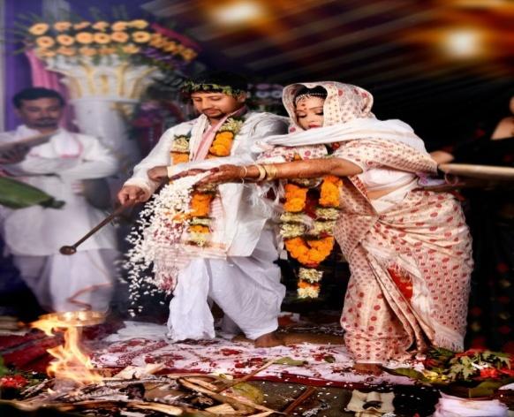
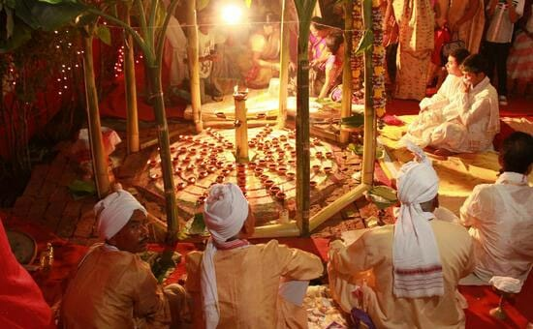
Other dishes include those made of lentils, vegetables, meat and some sweet dishes. The people of Assam prefer non-spicy foods and spices like cumin, coriander, mustard, ginger, garlic, fenugreek, cardamom and some ingredients that are local to Assam are generally used.

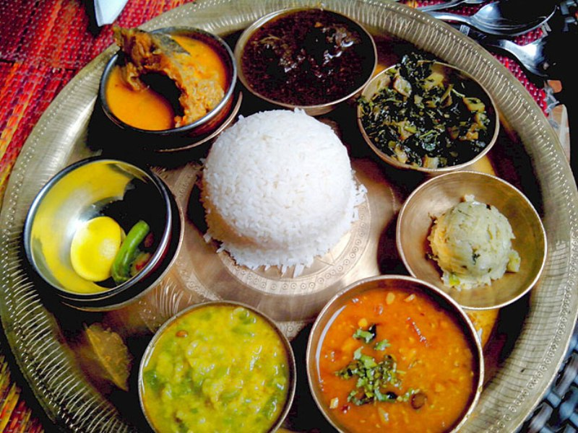
Image 5: Choklong Image 6: Assamese wedding

Image 7: An Assamese Thali
Photo courtesy: www.holidify.com
1.5.3. Traditional Dance Forms of Assam
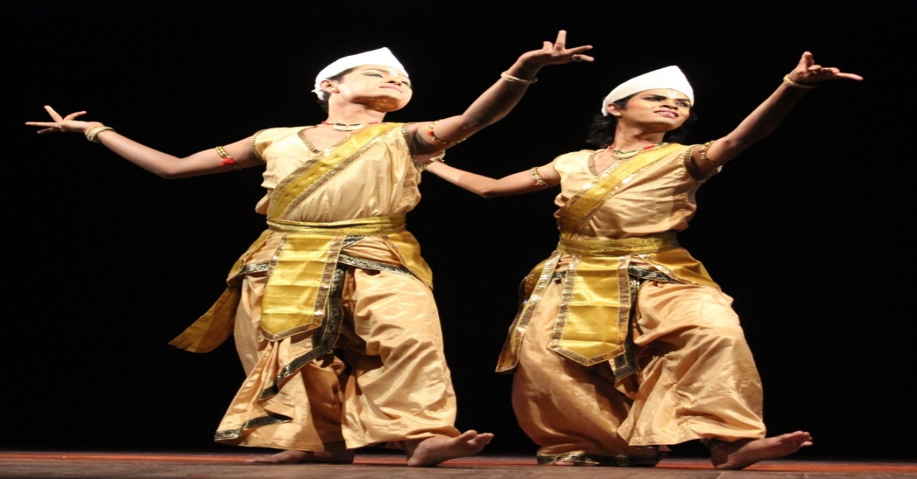
Ojapali, Devdasi, and Satriya are the major dancing styles of Assam. Oja or the lead dancer narrates a mythological story along with the fusion of dance and acting. It is of three types - biyah-gowa that presents Mahabharata stories with the rhythmic use of feet, sukananni which celebrate the worship of snake goddess Manasa, and ramayani is based on the Assamese version of Ramayana. Satriyawas developed and propagated by Sankardeva. Devadasi, deva-nati or nati-nas is a conventional temple dance that is performed by unmarried women who have submitted their lives to the presiding deity.

Image 8: A still from Satriya Nritya (Photo credit: Wikimedia commons)
1.5.4. Dress and Ornaments
Assamese people wear very simple dresses, most of which are hand-loomed. The women wear motif rich mekhela chador or riha mekhela. The men wear suria or dhoti, and over it, drape a type of cloth known as seleng. Gamosa is an indispensible part of almost all socio-religious ceremonies in Assam. The common people of Assam (the population in the villages) wear the dhoti-gamosa (men) and mekhela chador (women)as their traditional dress.
Assamese jewellery is usually handmade and the design depicts flora and fauna. The people are keen on wearing a beautiful and unique style of ornaments made of silver and goldand varieties of jewels. The jewellery is simple and decorated with ruby and minerals. The traditional ones worn by men are biri, magardana, matamoni, kundal, lokapara whereas the ones worn by women arekeru, karphul, kharu, aargathi, nalak,keyur and nupur.
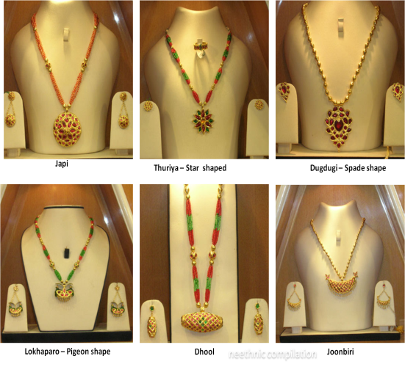
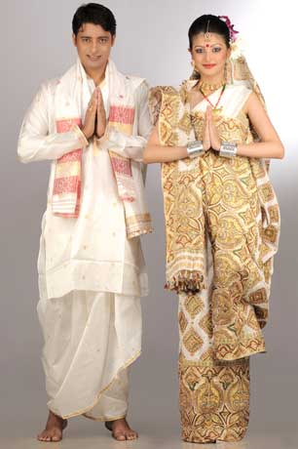
`

Image 9: Assamese Couple in traditional attire Image 10: Assamese traditional jwellery
(Photo Courtesy: www.shutterstock.com)
1.5.5. Religion
To sum up about the Assamese society we will lastly be stating about the religion. Assam is a land of diverse religion and people having faith in almost every religion of India is found here. Hindus, Muslims, Sikhs, Christians, Buddhists, Jains and people worshipping nature are also found here and live in peace and harmony.
1.6. Topic of the study
The topic of the dissertation is Word Formation Processes in Assamese. Word formation is a very vast area and this dissertation will discuss briefly about the various Word Formation processes with special reference to Assamese with proper examples. This is a very brief descriptive study with ample scope for further reasearch.
Chapter 2
Review of Literature

The development of Assamese is becoming more popular in the recent past. The first pioneering work in Assamese was Devananda Bharali’s‘AsamiyaBhasarMoulikBichararuSahityotChinaki’ which was published in 1912. His writings can be found in both in English and Assamese. He has written a variety of books on the different aspects of the Assamese language. The Assamese eminent author Dr.BanikantaKakati’s book entitled ‘Assamese its Formation and Development’ (1941) is one of the major but not pioneering work which deals with the roots of the Assamese language and grammar. Kakati gives a brief sketch of the land and its people, the influence of the neighbouring languages on Assamese and a chronological development of the language in two parts of which the first one is devoted to phonology. The publication of Kakati’s book is in consonance with the aims and objectives of the Department of Historical and Antiquarian studies in Assamese, as the book marks a distinct achievement in the history of research on the Assamese. It deals, as the tittle indicates, with the growth of the Assamese language and grammar and the treatment of subjects has been carried out on approved scientific lines.
As to the works carried out on word formation in Assamese, there is an abundance of recent works too, ranging from pure descriptive description to analysis from a computational perspective. For descriptive works, Saharia (2012) has given a very brief description of the various Word Formation processes in Assamese. The paper has a brief definition of each process along with a few examples. Baishya (2013), in her term paper “A note on Assamese Compound words” has described the various ways in which compound words are formed in Assamese and concludes that compounds in Assamese tend to be morphologically, phonologically active than derived words and also less syntactically active than phrases. Another paper by Roy and Purkayastha (2017), titled “A Suffix based Morphological Analysis of Assamese word Formation” is another work done which clearly describes the Assamese suffixes, their roles and usage in the language. Their work concludes with the fact that suffixation in Assamese contributes to the morphosemantics and morphosyntax of the language to a great extent. Nath (2019), has described all the various processes via which words are formed in Assamese with major focus on affixation and compounding. She describes the major inflectional and derivational affixes along with the functions they perform in Assamese. She also says that the compounding changes the final sound of the first word and the initial sound of the second word. So, to conclude compounding affects the phonological structure of a word. These were the recent descriptive come across so far.
As to the works done in the field of computational linguistics, there’s quite a bunch of them. Saharia, Sharma and Kalita (2010) have their paper on “Suffix-based Noun and Verb Classifier for an Inflectional Language” which is basically from a computational perspective where they develop a model that will categorize verbs and nouns from the input provided and give results. Rahman and Sarma (2016), in their paper “Analysing Morphology of Assamese words using Finite State Transducer” is another work done on Assamese from a computational perspective. They develop a model which can analyse a highly morphologically inflectional language and separate the root from all the affixes: inflectional and derivational. Their model gives an accuracy of 84.64%. The latest work in Assamese from a computational perspective is “Morphological Rule Formation for Nouns in Assamese to Develop Morphological Tools” by Das, Barbora and Sharma (2019) where they try to develop a morphological tool which will give them more accuracy in case of nouns by forming certain rules which can be fed to a program which will again help in the computational analysis of the language. This paper mainly focuses on the affixes which are attached to nouns.
Thus, these were some of the recent works done in Assamese with reference to Word Formation. Although the works done from a computational perspective are mainly related to affixes, still they come under word formation as affixation is a part of it. As to theoretical work, there is no theoretical work done in the field of word formation as such.
The scope of word formation is very high as it is a very vast field with many sub-fields and it may not be possible to cover each and every one of them in a single paper or thesis in detail. The upcoming scholars should grab this opportunity and use it properly so that more productive work is done which contributes to Assamese’s rich linguistic heritage.

Chapter 3
Objectives and Methodology

The basic purpose of this work is to present the various Word Formation processes in Assamese, which I have discussed in my research. Assamese is an Eastern Indo-Aryan language spoken mainly in the Indian state of Assam, of which it is the official language. It is spoken by over 1.5 million native speakers and serves as a lingua franca in the region. It has many dialects but my research will solely be confined to the different word formation strategies of standard Assamese.

3.1. Objectives of the study
The main objectives of the study are as follows:
- To draw the typological features of word formation in Assamese. It is to be observed as to how new words are being formed in a language.
- To know the authentic structure of the language.
- How the word formation processes contribute to increase in the vocabulary of a language.
- The study has high capability to enrich the academic sphere of the society as well as the language learners.

3.2. Data
As mentioned in Chapter 1, the proposed study is based on the Standard Assamese Language, which is mainly spoken in the various districts of Upper Assam.The study of the analysis is based on morphological processes through a linguistic point of view. Being a native speaker of Assamese, data has been collected from two main sources. They are:

3.2.1. Primary data
Being a native speaker of Standard Assamese, data has been collected through self-information sources. I have provided the necessary data for this study by acting as an informant. I have also collected data from persons like my parents, teachers, friends, relatives and so on who speak the same variety this has helped me to run a cross check on my own data.

3.2.2. Secondary data
Most of the other required information has been collected from secondary sources. Data has been collected from existing literature available in the form of books, journals, e-books, thesis, articles, novels and so on. Furthermore, data from the internet, social media has also been put to use in order to for a plausible hypothesis as to explain the reason behind certain causes which are seen the Word Formation processes.

Chapter 4
Word Formation in Assamese
4.1. Word Formation: An Overview
Word formation is the process through which new words are created. Word formation is sometimes contrasted with semantic change, which is the change in the meaning of a single word. The boundary between Word formation and semantic change can be seen of as a new-word derived from an old one and identical to it in form. The formation of words does not happen out of the blue, but rather, there are several processes through which new words are created. Let us consider language as a tool for communication and some vicissitudes it has undergone with the passing of time. The only means by which humans communicate is language (be it spoken or body language). It is the most vital tool of interaction between men. With time, language needs to change in order to fulfil the requirements of the people.
Following years of complete or partial neglect of issues concerning Word formation (by which we mean primarily derivation, compounding, and conversion), the year 1960 marked a revival – some might even say it as a resurrection of this important field of linguistic study. While written on completely different theoretical frameworks (Structuralist vs. Transformationalist), both Marchand’s categories and types of present-day English word formation in Europe and Lee’s grammar of English nominalizations instigated systematic research in the field. As a result, large number of seminal works emerged over the next decades, making the scope of word formation research broader and deeper, thus contributing to better understanding of this exciting area of human language.
Recent voices stressing the importance of investigating word formation in the light of cognitive processes can be interpreted from two general perspectives. How new words are being formed in a language? Why the process consists of a combination of morphemes that are rule-governed (when a new word is formed)? Cognitive linguistics concedes closely to the self-organizing nature of humans and their language, whereas generative–structuralist perspectives represent external boundaries as given in the institutionalized order of human language.

4.1.1. Types of Word Formation processes
The different processes via which words are formed in a language are pointed out below. Detailed description about these processes with special reference to Assamese will be made in the later sections of this chapter.

  - Inflection
  - Derivation
  - Compounding
  - Blending
  - Acronym
  - Calque
  - Back-formation
  - Clipping
  - Coinage
  - Reduplication
4.2. Word Formation processes in Assamese
Assamese word formation processes are mainly dominated by affixation and compounding, where the predominant morphological phenomenon is suffixation. Suffixation occurs both as inflection and derivation, and is usually concatenative. Though prefixes are also fairly frequent, the behaviour of the resultant words are often independent, use of suffixes in Assamese is more common than use of prefixes, and it is often more extensive than in other Indic languages and English. A preliminary survey by Sharma and Kalita (2010), where a sample of 1600 words from Assamese text (from the newspaper Protidin) and 1400 words from English text were taken led to the finding that about 48% of the words in Assamese are inflectional or derivational whereas in English the result was only 19%. Similarly, in a sample Hindi text of about 1000 words, 26% were inflectional and derivational.
The main sources of Assamese vocabulary are Tatsama (Sanskrit loanwords), Tatbhaba (word of Indo-Aryan origin), Desi(local/indigenous) and Videsi(loan words). The influence of neighbourhood has led to Assamese adopting many words from its neighbouring languages. Sometimes words are formed by two different free morphemes and at times there is a more complex formation of words. These are the various word formation processes with special reference to Assamese are illustrated in the next sub-sections.
4.2.1. Inflection and derivation
Although different types of Word Formation processes are available, all of them bring either inflectional or derivational changes. Therefore, inflection (also called inflexion) and derivation are the two main processes of word formation in Assamese language. The major differences between inflection and derivation are listed below.
Inflection | Derivation
- Produces grammatical variants of the same word.  - Modifies a word to express different grammatical categories such as tense, mood, voice, aspect, person, number, gender and case.  - Does not change the meaning of a word | - Produces a new word on the basis of an existing word.  - Changes the word class (also called parts of speech, form, class, lexical class, syntactic category).  - Modifies the meaning of the root.
Table 2: Inflection Vs. Derivation
Derivation is a very common morphological word formation process for Assamese. In Assamese, a large number of words generally consist of a combination of free morphemes and some bound morphemes. The bound morphemes could either be inflectional or derivational. The derivational morphemes are always bound. Positionally such derivational morphemes could either be a suffix or a prefix. There is no presence of any infix or circumfix in Assamese. The process of suffixation and prefixation could be broadly described as the process of affixation. Derivational morphemes generate new words from the existing ones, thereby widening the scope of expression. Derived words do not fulfil any syntactic function but they meet only morphological and semantic necessities. This is true in the case of Assamese derivatives. Assamese derivational morphemes are described in the following section.
4.2.1.1. Class-maintaining
Class-maintaining derivational morphemes in Assamese are those morphemes that don’t change the word class of a word, i.e. on adding a class maintaining morpheme to any word generates words of the same class, verbs from verbs, adverbs from adverbs, nouns from nouns, and adjectives from adjectives. Here, also the processes involved are both suffixation and prefixation. In Assamese, the process of suffixation is more productive than the prefixation. Some examples are given below:
Verb form |  |  |  | Causitive form
 | Root Form | Verb Form | Meaning | Causitive stem | Causitive verb | Meaning
 | /pɔrh/ | /pɔrh-o/ | (I) read. | /pɔrh-ua/ | /pɔrua-õ/ | to teach
 | /kɔr/ | /kɔr-o/ | (I) do. | /kɔra-a/ | /kɔrua-õ/ | Get it done.
 | /lik^{h}/ | /lik^{h}-o/ | (I) write. | /lik^{h}-a/ | /lik^{h}a-õ/ | Get it written.
Table 3: Class-maintaining Affixes (verbs and causative verb)
On a closer analysis it will be seen that there are four allomorphs to derive causatives from verb roots in Assamese. They are -ua-, -ija-,-oa- and -a-. In view of the frequency and ease in writing the -a- allomorph could be considered as the principal causative bound morpheme in Assamese. The conditions required for occurrence of these four allomorphs are detailed as follows:

  - -ua-: This derives a small number of causative verb stem from non-causative verb roots. All of them are listed below illustrating their use in past and future tense forms. Examples are given in the following table:
Non-causative verb root | Gloss | Causative stem | Meaning | Past | Future
/ur/ | fly | ur-ua | to make something fly | ur-ua-lõ | ur-ua-m
/pɔrh/ | read | pɔrh-ua | to make study | pɔrh-ua-lõ | pɔrh-ua-m
/k^{h}a/ | eat | k^{h}u-ua | to feed | khu-ua-lõ | khu-ua-m
Table 4: Causative verb formation using -ua- morpheme
  - -ija-: This derives a limited number of causative stems from non-causative verb roots.
Non-causative verb root | Gloss | Causitive Stem | Meaning | Past | Future
/ola/ | come out/get ready | ola>ul-ija | cause to bring out/get ready | ul-ija-lõ | ul-ija-m
/mar/ | beat | mar>mɔr-ija | cause to beat | mɔr-ija-lõ | mɔr-ija-m
Table 5: Causative verb formation using -ija- morpheme
  - -oa-: This derives a limited number of causative stems from non-causative verb roots.
Non-causative verb root | Gloss | Causative stem | Meaning | Past | Future
/kɔr/ | do | kɔr-oa | make to do | kɔr-oa-lõ | kɔr-oa-m
/xik/ | learn | xik-oa | make to learn | xik-oa-lõ | xik-oa-m
Table 6: Causative verb formation using -oa- morpheme
4.2.1.2. Class-changing
Class-changing derivational morphemes are those that change class-membership of the derived words. In other words, the root words and the derived words have to be allotted different class-membership. Thus, in Assamese, there are adjectives, adverbs and verbs which are derived from noun stems; adverbs, verbs and nouns that are derived from adjective stems; and nouns, adjectives and adverbs that are derived from the verb stems. The morphological process involved is affixation. While most of the derived forms are constructed either by suffixation or prefixation, there are also cases where both suffixation and prefixation are resorted to derive further forms from derived ones.
There are nine major types of class-changing derivation by suffixation. They areas follows:

  - Verbs derived from nouns, e.g.: -ua: ag + -ua=agua ‘to proceed’
  - Adverbs derived from nouns, e.g.: -e: din + -e = dine ‘daily’
  - Adjectives derived from nouns, e.g.: -i: beg + -i = begi‘fast’
  - Verbs derived from adjectives, e.g.: -a: atɔr + -a = atɔra ‘to remove’
  - Adverbs derived from adjectives, e.g.: -e: gupɔn + -e = gupɔne ‘secretly’
  - Nouns derived from adjectives, e.g.: -i: salak + -i = salaki ‘cunningness’
  - Nouns derived from verbs, e.g.: -a: xatur + -a = xatura ‘swimming’
  - Adjectives derived from verbs, e.g.: -i: man + -i = mani ‘respected’
  - Adjectives derived from verbs, e.g.: -i: xuka+ -i = xukai ‘dry’
Suffixes can be attached to any class of words except pronouns and they can change the word class and it can be seen from the examples given above.
4.2.2. Affixation
Affixation is the most common word formation process via which new words are formed. Affixation is generally done through the use of bound morphemes and both inflection and derivation come under this process. Where affixes are attached to a root or stem or a base, they form a new word. Affixes themselves do not carry any meaning but when they are attached to a root, it influences the semantic meaning of the root. An inflectional affix modifies the form/grammatical category of a word i.e., tense, person, number, gender, case etc. For e.g.: -bur in manuhbur ‘people’. Contrary to that, a derivational affix modifies the parts of speech of the root, and also changes the grammatical category i.e. from noun to adjective, adjective to adverb and so on. For e.g.: -ijota in manobijota ‘humanity’.
In Assamese, affixes are classified into four different categories based on their roles played in sentence which are prefixes, suffixes, pratyayas and vibhaktis.
4.2.2.1. Prefixation
Prefixes are placed in front of the root and represent a different meaning of the word in context. In Assamese, there are some prefixes have their origin from Sanskrit. They are:

  - /ɔpɔ/ - It denotes a negative meaning of neglect, insult, insanity, ugliness, etc. E.g: /ɔpɔ-man/ - opposite behaviour/treatment, disrespect or insult.

  - /ɔ/ - It represents of opposite/dissimilar to the root word to which it is attached to. E.g.: /ɔ-rini/ - ungrateful person, /ɔ-ghori/- homeless person, /ɔ-kopot/-, frank/honest person.

  - /dur/ - A prefix signifying bad, negativity. E.g.: /dur-akaŋkhja/ - evil or bad desire, /dur-atma/- bad soul, wicked malevolent etc.

  - /prɔ/ - A prefix implying excellence, excessiveness etc. E.g.: /prɔ-kompon/ - excess vibration, great agitation.
4.2.2.2. Suffixation
Assamese has a huge stock of suffixes. They play a very vital role in terms of the meaning of a word. In Assamese, suffixes can be attached to nouns, adjectives, adverb and verbs. The suffixes which are attached to the end of a root word in order to enhance the meaning or to indicate indefiniteness, definiteness, possibility, request, doubt, wish of the speaker of writer, speaker and so on. In Assamese suffixes are both inflectional and derivational in nature. The examples are as follows:
- Noun + Suffix
Noun | Suffix | Word | Gloss | Meaning
/lora/ | -bur | lorabur | lora‘boy’ +bur pl.cl | boys
/goru/ | -zak | goruzak | goru‘cow’ + zakpl.cl | a herd of cows
/k^{h}eti/ | -ɔk | k^{h}etiɔk | k^{h}eti‘crop field’ + ɔkagentive marker | farmer
Table 7: Suffixation with Nouns

- Pronoun + Suffix
  - teu- luk = teuluk
3sg.hon + cl.pl.hon
‘They’ (Honorific)
  - xi - hot = xihot
3msgcl-pl
‘They’ (distant, non-honorific)
  - i-hot = ihot
3msgcl.pl
‘They’ (near, non-honorific)

- Adjective + Suffix
  - daŋɔr-zoni= daŋɔrzɔni
big cl.hon
‘elder one’
It is to be noted here that although -zoni is the female honorific classifier, when adding it to the adjective daŋɔr ‘big’ it gives out the meaning of elder apart from expressing honorificity.
- Verb + Suffix
  - ga- ɔk= gaiɔk
sing agen
‘Singer’
  - k^{h}el - uoi = k^{h}eluoi
play agen
‘Player’
Note that there are also other agentive suffixes which can be added to other verbs to make agentive nouns, like -eta in bikreta ‘seller’ and so on.
- Adverb + suffix
  - rati -loi= ratiloi
night posp
‘at night’
  - kali -loi = kaliloi
tomorrow posp
‘tomorrow’
4.2.2.3. Pratyaya
Pratyayas are affixes which create a new category of word irrespective of classes by inflecting its root word. E.g.:

  - ɔxɔm + ija = ɔxɔmija
Assam ‘noun’ pratyaya
‘An Assamese person/entity’
  - gau + olija = gaolija
village ‘noun’ pratyaya
‘A villager’
4.2.2.4. Vibhaktis
Vibhaktis are affixes use to reflect the contextual meaning of a noun in sentence according to their position. In English we call them case markers. Consider the following sentences:

  - /mɔi ram-ɔrkɔthakɔisu/
‘I am talking about Ram.’
  - /mɔi ram-ɔkkɔthakɔisu/
‘I am talking to Ram.’
In the first sentence, adding the -ɔrvibhakti to the word Ram gives us the meaning as something about Ram or belonging to Ram whereas in the second sentence, the -ɔkvibhakti added to Ram gives out the meaning of to Ram. Hence, vibhaktis are added to reflect the proper meaning as per as the context of the sentence.

4.2.3. Reduplication
Reduplication is a morphological process in which the root or stem of a word or even the whole word is repeated exactly or with a slight change. Reduplication is of two types: full and partial and it is found in every language.
Full reduplication consists of reduplication of the whole word (both open and closed class of words) and expressives. Both these types exhibit some functional and semantic specifications. As regards partial reduplication, the two broad categories: echo-formations and expressives which are found to be present in Assamese. Each of these categories of partially reduplicated structures can again be classified into different subcategories depending upon their formal shape. It is through the different ways of phonological alterations, which make them different in shape resulting in forming different subcategories. Examples showing the reduplication in Assamese are listed below:
- Full Reduplication:
  - /kane-kane/ ‘very secretly’
  - /pete-pete/‘secret’
  - /sɔkue-sɔkue/ ‘through hints’
  - /ki-ki/ ‘what’
  - /kun-kun/ ‘whosoever’
  - /zie-zie/ ‘those of who’
  - /hate-hate/ ‘then and there’
- Partial Reduplication:
  - /mas-tas/ ‘fish and the like’
  - /saul-taul/ ‘rice and the like’
  - /kitap-sitap/ ‘book and the like’
  - /bohi-sohi/‘copy and the like’
  - /kati-kuti/ ‘cutting (changing) and the like/deduction’
  - /sati-tati/ ‘umbrella and the like’
  - /zunuk-zanak/ ‘tinkling’
  - /tipik-tapak/ ‘falling of raindrops’
  - /kɛr- zɛr/ ‘bargaining’
  - /udhai-mudhai/ ‘vigorously’
4.2.4. Compounding
In Assamese, compounding is done by adding two different roots. Both the roots carry some meaning. Sometimes the meaning is inherited by one of the two roots and sometimes they denote a meaning which is very different from the individual or combined meaning of the roots. In Assamese, when two roots are combined together to form a compound word the final sound of the first morpheme and the initial sound of the second morpheme change generally (subject to phonological conditions) and it happens both with vowels and consonants. Some compounds which refer to different places of Assam are as follows:
- Compounds formed using bari ‘land attached to the house’ and hat ‘market’:
  - /zaluk-bari/
  - /lila-bari/
  - /mohan-bari/
  - /biru-bari/
  - /guwa-hati/
  - /ada-bari/
  - /panza-bari/
Compounds are of two types: Endocentric and Exocentric. The description along with its presence in Assamese is described below:
4.2.4.1. Endocentric Compounds
In endocentric compounds, the meaning is inherited by one of the two words which is combined together to create a new lexeme. It is further divided into two categories: right-headed and left-headed. Right-headed are those in which the word to the right acts as the head and in case of left-headed the word to the left acts as the headword.

  - /gozmuk^{h}/ = goz ‘elephant’ + muk^{h} ‘face’ - one who’s face is like an elephant
  - /bidjaxagor/ = bidja ‘knowledge’ + xagor ‘ocean’ - knowledge like an ocean

4.2.4.2. Exocentric Compounds
In Assamese exocentric words, the internal meaning is not carried by any of the both lexemes. They create a different meaning altogether. Some examples are as follows:

  - /binapani/ = bina ‘a sort of Indian lute’ +pani ‘hand’ - one who has the lute in her/his hand= The goddess of learning and music, i.e. Goddess Saraswati.
  - /nilambɔr/ = nila ‘blue’ + ɔmbɔr ‘cloth’ - one who wears blue clothes = the elder brother of Lord Krishna.
Assamese is a partially inflectional language where in general, only the last word of a noun phrase is inflected. Here, the nature of constructions such as the modifier-head or attributive-head constructions is difficult to determine. It can be seen in the following examples:

  - /bɔr + kerani/= /bɔrkerani/ ‘head clerk’
  - /ahɔt + gɔs/= /ahɔtgɔs/ ‘a kind of tree/pipal tree’
Thus, the discussion above gave us a brief description about compounding.
4.2.5. Back-formation
In etymology, back-formation is the process of creating a new lexeme, usually by moving actual or supposed affixes. Back-formation is different from clipping in that back-formation may change the part of speech category or the word’s meaning. In clipping shortened words are created from longer words, but does not change the part of speech category or the meaning of the word. Some examples are:

  - /da/ - /dada/ ‘elder brother’
  - /ba/ - /baidɛu/ ‘elder sister’

4.2.6. Blending
A blend is a word formed from parts of two or more words. Blends deal with the action of abridging and then combining various lexemes to form a new word. Some examples of blends in Assamese are:

  - kunop +kowandho+chatyo=/kund^{h}ɔs/ ‘ugly’
  - xouborno +daru= /xonaru/ ‘a kind of tree’
4.2.7. Clipping
Clipping is another word formation process in which a part of the word is retained giving rise to another word without any difference in meaning or change in word class. Clipping is of mainly of two kinds: fore-clipping, back clipping, where in fore clipping the initial part of the word is clipped of leaving the later part (as in 18(a) and 20(b-d)), and back-clipping where the later part of the word is clipped leaving the initial part (20(a)). In both cases the unclipped original may be either a simple or a composite. Some examples are as follows:

  - /dɛu/- /dɛuri/ ‘priest’
  - /mauri/ - /g^{h}atmauri/ ‘orphan (girl)’
  - /koŋwar/ - /razkoŋwar/ ‘prince’
  - /koŋwari/ - /razkoŋwari/ ‘princess’
There are also two kinds of clipping: middle clipping and complex clipping, where in middle clipping, the middle of a word is retained and in complex clipping one part of the original word remains intact.
4.2.8. Loanwords
Loanwords are words adopted by the speakers of one language (target language) from a different language (the source language). A loanword can also be called a borrowed word. It is the consequence of sociocultural contact between two languages. Borrowing of words can go in both directions between the two languages in contact, but often there is an asymmetry, such that more words go from one side to the other. In this case the source language has some advantage of power, prestige and/or wealth that makes the objects and ideas it brings desirable and useful to the borrowing language. In present-day Assamese, we will find a ton of loanwords as the present generation of Assamese speakers are incorporating more and more of these loan words (either from English of Hindi) into Assamese.
4.2.9. Calque or Loan Translation
Generally, a calque refers to loan translation. It is a word or phrase borrowed from another language by literal, word-for-word or root-for-root translation. Examples of calques in Assamese are as follows:

  - /batorikakot/ ‘newspaper’
  - /swarnazug/ ‘golden age’
  - /xonalizojonti/ ‘golden jubilee’
  - /kondua gas/ ‘tear gas’
4.2.10. Coinage
It is one of the least common processes of word formation in English and other languages. It is the invitation of totally new terms which were not present in a language in the previous times. Some examples are:

  - /zalponzi/ ‘network’
  - /oŋkorupon/ ‘digitization’
4.2.11. Abbreviation or Acronym
An acronym is an abbreviation formed from the initial components in a phrase or a word. These components may be individual letters or parts of words. Some Assamese acronyms are:

  - /ɔgɔpɔ/- Assam Gana Parishad
  - /aasu/ - All Assam Students Union
  - /akrasu/ - All Assam Koch Rajbongshi Students’ Union
4.2.12. Eponym
An eponym is a person or an object after which a particular place, tribe, era, discovery or other item is named or thought to be named. Some examples of eponyms in Assamese are:

  - /d^{h}odɔrali/ ‘a road in Golaghat named after the lazy people who were made to construct it’
  - /kolia-b^{h}omora/ ‘the bridge in Tezpur over the Brahmaputra named after an Assamese general who fought for Assam’
4.3. Loan words in Assamese
A loanword is a word adopted from one language (the donor language) and incorporated into another language without translation. This is in contrast to cognates, which are words in two or more languages that are similar because they share an etymological origin, and calques which involves translation.
Loanword adaptation is always fascinating as it bears the traces of native phonology, default settings of universal grammar and adaptation as perception and perceptual similarity (Kang 2010). The loanwords of Assamese phonology which are borrowed from English with reference to the constraint ranking approach are embedded within Optimality Theory. Assamese, an Indo-Aryan language spoken in the North-Eastern part of India shares some common features with English phonology. Both the languages are characterized by language specific phonemic inventories and phonotactic principles. The phonological processes that loanwords undergo and patterns that emerge as a result of this process of borrowing happens not only at the segmental level but also at the syllabic level.
Chapter 5
Conclusion
Word formation in Assamese is a very wide topic and there is ample scope for research to be carried on in this topic. In fact, there is very less work done in this field as already discussed in chapter two. Given time and attention will lead to proper work which will further lead to contribution in every sub field of Linguistics as every field is related in some or the other way to each other.
Common word formation processes like affixation and their interaction with loan words is also an interesting area to look into because these words seem to have taken similar affixes and perform the similar function which the affix helps in doing. For example, people tend to say ‘Whatsapp me’ or ‘Tag me’, in Assamese which makes the loan word a verb and in some other place they use the loan word as a noun. Although scholars like Kakati and Goswami have done their part in this field by giving us an overview about the various word formation processes an providing all the affixes, still there is much work which is left to be done.
To conclude, each of the word formation processes can make up a single thesis if they are worked on detail covering every phonological, morphological, syntactic and semantic aspect of the resultant of that particular process. Research in this field is left open and given the proper encouragement and opportunity, I’d be very keen to take it up and contribute to the field of research in Assamese.

Bibliography

Abbi, Anvita. 1990. Reduplication in Tibeto Burman Languages of South Asia in Southeast Asian Studies, Vol. 28, No 2.
Boro, M. Ram.1990. Assamese and Boro: A Comparative and Contrastive study. N. L. Publications, Panbazar, Guwahati
Crystal, David. 2008. A Dictionary of Linguistics and Phonetics. Blackwell Publishing, USA.
Goswami. G. C. 1982. Structure of Assamese. Gauhati University Press.
Das, Palash. BarboraMadhumita& Sharma, Utpal. 2019. Morphological Rule Formulation for Nouns in Assamese to Develop Morphological Tools. Language in India www.languageinindia.com ISSN 1930-2940 19:2
Kakati, Banikanta. 1941. Assamese: its Formation and Development. Government of Assam, Guwahati, Assam.
Medhi, Kaliram. 1936. Assamese Grammar and the Origin of Assamese Language. Publication Board Assam, Guwahati.
Nath, Bediskiva. 2019. Word Formation in Assamese: A Preliminary Investigation. Abhyantar SCONLI-12; ISSN: 2348-7771
Pathak, Ramesh. 1985. AsamiyaBhasarItihas. Journal Emporium, Nalbari.
Roy, Bipul and Purkayastha, Bipul, S. 2017. A Suffix Based Morphological Analysis of Assamese Word Formation. International Journal on Recent and Innovation Trends in Computing and Communication, Volume 5, Issue 3
Saharia, Nabanath. Sharma, Utpal&Kalita, Jugal. 2010. A Suffix-based Noun and Verb Classifier for an Inflectional Language. 2010 International Conference on Asian Language Processing. Harbin, China, December 28-30, pp: 19-22

Kakati (1962): Assamese, its formation and development: A scientific treatise on the history and philology of the Assamese language.

