A Project Report on
PRONOUNS IN HRANGKHOL

A Dissertation submitted to the department of Linguistics, ASSAM UNIVERSITY, Silchar as a part of academic requirements for the fulfilment of Master Degree in Linguistics from Assam University
2020.

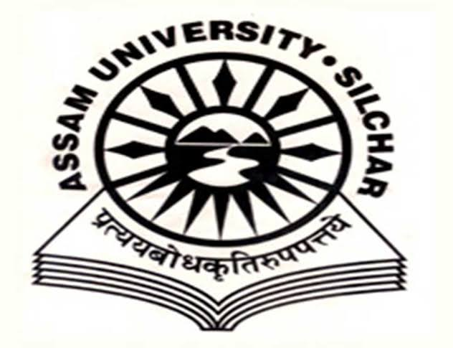

Roll: 042018 No : 2083100006
Registration No: 05-130045253
Department of Linguistics
Rabindranath Tagore School of Indian Language and Culture Studies
Assam University, Silchar
India-788011
Year of submission: 2020

Department of Linguistics,
Rabindranath Tagore School of Language & Cultural Studies,
Assam University, Silchar (A Central University established by an act of Parliament 1994)

CERTIFICATE

This is to certify that that the dissertation project entitled, “PRONOUNS IN HRANGKHOL” is submitted by Elizabeth Hrangkhol bearing Roll: 042018 No : 2083100006 and Registration No: 05-130045253 as a part of academic requirement for the fulfilment of Master Degree in Linguistics in Assam University, Silchar. This work has not been submitted anywhere previously by anyone for fulfilling the requirement of any Degree. It is further certified that the candidate has compile with all the formalities as per the requirements of Assam University. I recommended that the Dissertation may be placed before examiners for consideration of awards of Master Degree from this University.

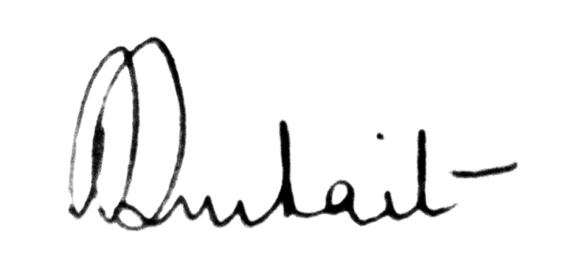

Name & Signature of Supervisor

(Signature)
Dr. Paramita Purkait,
Assistant Professor
Department of Linguistics
Assam University, Silchar

DECLARATION

I, Elizabeth Hrangkhol, bearing Roll: 042018No: 2083100006, and Registration No. 05-130045253 hereby declare that the content of the Dissertation entitled “PROUNOUNS IN HRANGKHOL” is a genuine and work on my own. The content of this work has not been submitted in part or whole, to any institution including this University, for any Degree or Diploma.
This Dissertation is submitted to the Department of Linguistics, Assam University as a part of academic requirement for the fulfilment of Master of Arts in Linguistics.

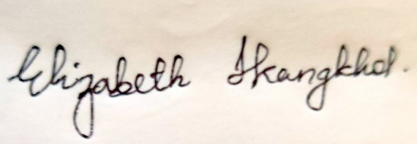

Dated: 05/10/2020
Candidate: Elizabeth Hrangkhol
Place: Assam University, Silchar

ACKNOWLEDGEMENT

In the utmost place I thank God for his unfailing love.
I also extend my heartiest gratitude to my supervisor, Ma’am Paramita Purkait (Asstt, Professor of Linguistics Department, Assam University, Silchar.) for her selfless and constant support to which words run short to describe her guidance in completing my Dissertation.
I express my profound sense of gratitude to our professor, Dr.S. Ganesh Baskaran (Head of the Department, Linguistics Department of Assam University, Silchar).For providing all essential and needful study material in departmental library as well.
I acknowledge gratefully the help and motivation that I got from Linguistics Scholars, friends and family members, which empower me to keep going on till I completed my project.

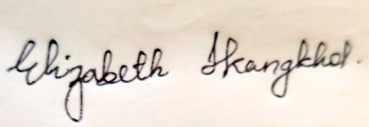

Elizabeth Hrangkhol
Master of Arts in
Linguistics Department
Assam University, Silchar
Dated: 05/10/2020

ABBREVIATIONS

HRK=Hrangkhol
PL=plural
SG= Singular
FUT=Future
FIG= Figure.
VIZ= Namely
i.e,= That is.

LIST OF MAPS

Map no.page no.

1. Assam map 4
2. District Map. 4

LIST OF FIGURE

Figure no. Page no.
Fig 1.1 4
Fig 1.2 4
Fig 2.0 6
Fig 2.1 7
Fig 2.2 8
Fig 2.3 9
Fig 2.4 10
Fig 2.5 11

CONTENTS

Certificate
Declaration
Acknowledgement
Abbreviation
List of map
List of figure
CONTENTS
CHAPTER 1: The Hrangkhol Language and Community. 3-11
Introduction 3
1.1 The Hrangkhol Language 3
1.1.1 Geography and Population 3-4
1.2 Dialects of Hrangkhol 5
1.3 Vowel phonemes of Hrangkhol 5
1.4 Society and Culture of Hrangkhol 6
1.4.1 Marriage system 6-7
1.4.2 Hrangkhol Traditional Festival 7-8
1.4.3 Dress Patterns and Ornaments 9
1.4.4 House and Art and Handicrafts. 10
1.4.5 Art and Handicrafts 11
CHAPTER 2: Review of Literature 12-13
CHAPTER 3:Objectives and Methodology 13-14
3.1 Objectives of the study 14
3.1.1 Data 14
3.1.2 Primary data 14
3.1.3 Secondary data 14
CHAPTER 4: Pronouns in Hrangkhol 14-17
4.1 An overview 14-15
4.2 Pronouns 15
4.2.1 Personal pronouns 15-16
4.2.2Demonstrative Pronouns 16
4.2.3Interrogative Pronouns 16-17
4.2.4Possessive Pronouns 17
4.2.5. Reflexive Pronouns 17
CONCLUSION 18
BIBLIOGRAPHY 19

Chapter 1

The Hrangkhol Language and Community.

1.0. Introduction
Hrangkhol is one of the Tribes /Community of Northeast India .It is mostly only in some part of the Northeast. It is also recognized by the 6th schedule tribes of the Indian Constitution as per the law.The word Hrangkhol means ‘mihuaisen’which means ‘courageous warrior’.The term Hrangkhol is a compound word ‘hrang’’courageous warrior’ and ‘khol’ ‘gathering group’ which literally means ‘a courageous warrior staying together’. Linguistically, Hrangkhol belongs to Kuki-Chin sub-group of the Tibeto – Burman language family.Like many other tibal people of Northeast India, Hrangkhol is well known for their rich linguistic and cultural heritage inherited from their forefathers since time immemorial.
Here,in this chapter it will describe about the Hrangkhol language and its geography and population, its dialects,and also about the Hrangkhol society and cultural aspect.
1.1.The Hrangkhol Language
1.1.1. Geography and Population

The North Eastern part of India comprises of the eight sisters of Assam, Meghalaya,Mizoram,Manipur,AndraPradesh,Nagaland, Tripura and Sikkim.It is a veritable Tower of Babel which according to the census report of 1971 has a total of 220 languages.There are five language families namely :Dravidian,Indo-Aryan, Austro-Asiactic,Sino- Tibetan and Tibeto –Burman.

However,Hrangkhol in DimaHasao,Haflong the headquater,majority of the Hrangkhol are there more than the other parts of the states of Northeast.It is recognised as the 6th schedules tribe of the Indian Constitution along withe the tribes of Biate,Hmar ,Thadao,andDimasaetc.The Hrangkhol community is not in a majority in number,but geographically this community are the permanent recendent as well as well known with the native language in the places.It is also spoken in some part of Mizoram,Meghalaya and Barak velley in some part of the district of kamringanjviz: magura,manikbond etc.
According to the population census of India 2011,among the total population of Assam 13,257,272 the majority of them were comprise as Hindu i.e 10,013,013 75.52% and a minority were Muslims which is 21.34% i.e 2,830072 and the rest of remaining were Christians and Sikhs i.e 414,187, 3.14%

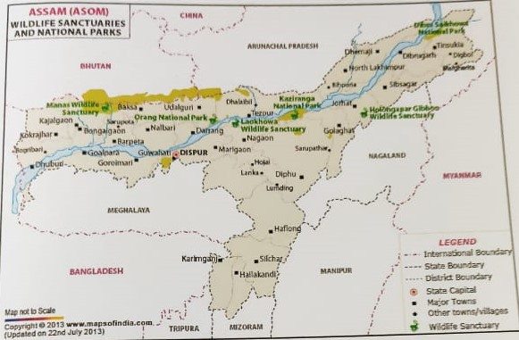
Fig 1.1. Assam map

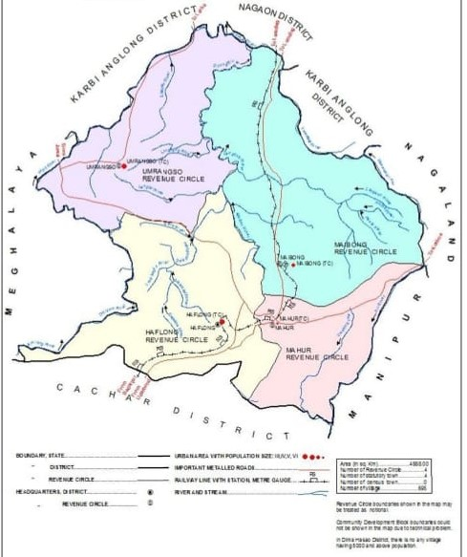

Fig 1.2.Dimahasao District map

1.2 Dialects of Hrangkhol
Hrangkhol Dialects :The Hrangkhol tribe has its own dialect known as “Hrangkhol Chong”.Like many of the tribals as Hrk is also under the sub group of Kuki-Chin language. Hrangkhol is one of the 21 schudled tribes of Tripura state of India. They are mainly dwelling in the Teliamura sub- division of West Tripura and the Ambassa sub – division of Dhalai district they all speaks Hrangkhol language of Kuki language which is of Tibeto – Burmese origin.As we can see about the Learner books of Hrangkhol Language author by Trisha Borgohain in the Tezpur University.
At present the people of Hrangkhol people broadly divide in two or some minor part of the Northeast state mostly in Assam and Tripura .The west part of Tripura and the East part they speak a bit different from the Assam part of the DimaHasao district but literacturally they use the same Bible which the Roman script which mainly includes phonologically and morphological features.

1.3 Vowel phonemes of Hrangkhol

 | Front | Central | Back
High | ᵢ |  | ᵘ
Mid | ᵉ | ᵊ | ᵒ
Low |  | ᵃ

TABLE 1. VOWEL PHONEMES

Hrangkhol exhibits the basic six vowel system found in Kuki- Chin and most of its descendants. The five vowels which can be categorised into three levels of tongue height: high, mid, and low. A three way contrast of front, contrast and back are also distinguished in terms of the parts of the tongue raise.

1.4 Society and Culture of Hrangkhol
The society and culture of Hrangkhol is very rich in their ethnic and the various types of custom and tradition, like the social institution, marriage customs, it is the most important and honourable one. According to the Hrk. Customary Law, girls can marry between 18 – 24 and a man between 24-30 years. Certain customs are followed by Hrk. Tribe with regards to birth. When a child is born to a family, they are named on different days depending on their gender, i.e if a male child the named is given on 11th day but if it is a female child, the name is given on the 9th day. As the symbol of the birth of new born baby. Hrk are depending on patriarchal family, the father has more power than the mother in all sense.
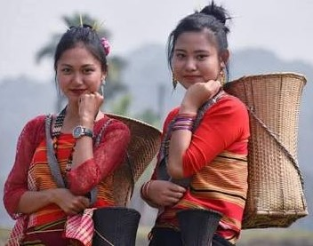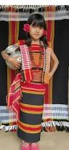
Fig 2.0 Hrangkhol girl in traditional attires

1.4.1 Marriage system
In Hrangkhol tradition, both the bride and the groom should be of the same community. Marriage within a clan is discouraged but not prohibited. Polygamy is highly forbidden among the Hrangkhols. In case of legal marriage (Hruoipui), the parents of a marriageable age send a proper to the bride’s family. The proposal is send in the form of ‘kutchoi’ which includes a piece of clothes ,pan etc. If the kutchoi is accepted then it indicates agreement, if it is send back it is not accepted or indicates deny. In Hrangkhol tradition Kuvaichu is the practice where the bride value is settled. After the negotiation of the bride value, manchatzu(rice beer) is offered to the elderly people. On the day of ceremony different types of rice beer is served in differently as viz. a) Sarchanzu-It is offer to the youths.
b) Puzu –It is offered to the maternal uncle
c) Nuchazu – It is offered to the brother’s and other male relatives of the bride.
d)Nuruozu – It is offered to the sister and other female relatives of the bride.
But nowadays, with the change of the sex and natural environment, the same rule are not practised. Marriage is always practicable through the mutual lover of man and women. Nowadays most of them are converted into Christianity religion so mostly they follow the Christian holy matrimony as a church marriage.

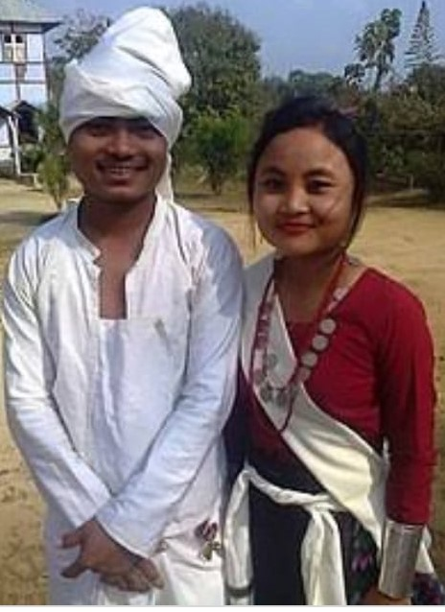
Fig 2.1. Hrangkhol Couple.

1.4.2Hrangkhol Traditional Festival
The Hrangkhol festival is mostly celebrates during spring and winter season on of the most popular festival of Hrk. Which the district also give official holiday is ‘Rualsafak’ and ‘Parngot’ there are various kinds of festival but the earlier mentioned two were the most useful and remarkable one.
Rualsafak is a harvesting festival. It also bids goodbye to the passing year and welcomes the new year. This festival is observed within the last part of January and the first part of February. In this festival, all young boys and girls and the entire village people take active part in various role like dance, folksong, games etc. The festival is celebrated for two days.
Parngot festival is one of the most important festival of Hrk. Parngot means a day of collecting flowers on presentation of flowers. Earlier people were very fond of collecting flowers for the use of some physical decoration as well. So the group of youth from respective villages concerned have to engage one day social work for collection of various kinds of flowers from jungle during middle part of summer season.

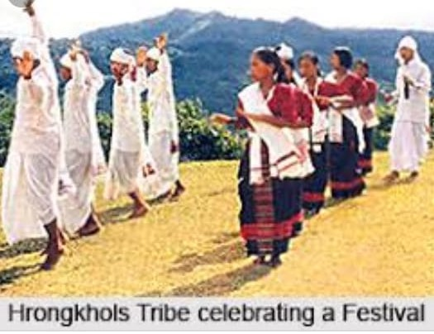
Fig 2.2. Hrangkhol Traditional Dance

1.4.3 Dress Patterns and Ornaments
The Hrangkhol attire is of the simplest description, generally man wears lukom(turban) on their head and a narrow Dhutii, a narrow white cloth passed one round the waist and between the legs with a fringed end hanging down infront and rear. A woman wear puanbom, a cloth covering from the waist to just below their knee, and lungbom, a cloth covering from their breast to the knee. Both male and female keeps their hair long and ties in a knot at the back of their head. The knot is fastened with samkil(hair-pin).

Ornaments: Women were very fond of ornaments, they wear bangles, earring with ancient type of coins or silver and is very precious and gold, their ears were full of earring with heavy jewellery and it is called kuardoi and bangles which it is called sumbanhrial(bracelet) and irthei (necklace).
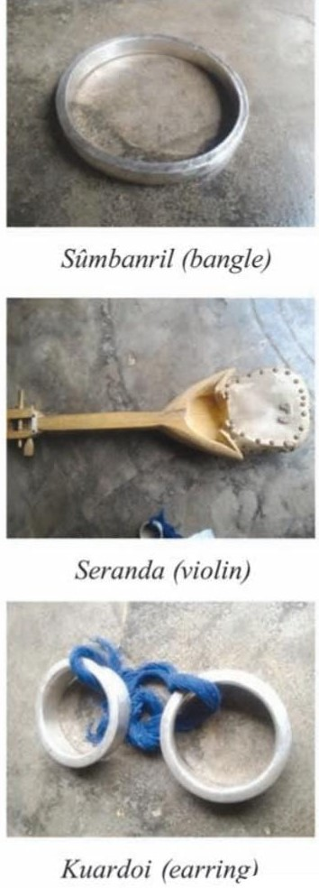
Fig2.3. Hrangkhol musical Instruments.

1.4.4 House and Art and Handicrafts.

The Hrangkhol houses are built entirely of bamboo with a machang floor raised with an approximate of 3 to 4 ft. above the ground. Most of the Hrangkhol houses are built one I shaped with two or three compartments are called banglai. The space of some sangka are enclosed with bamboo in an open air and it is made with mat wall of bamboo with three or four feet height to prevent the small children from falling over.

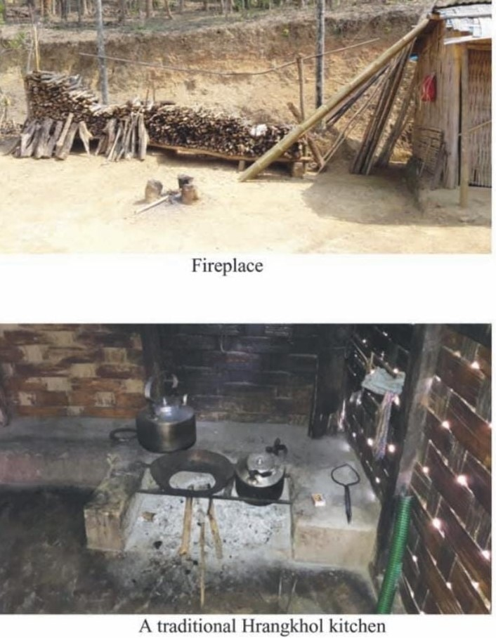
Fig2.4.Kitchen

1.4.5Art and Handicrafts
The Hrangkhols are very fond of cane and bamboo work for their domestic use. The below image are the various kinds of handicrafts

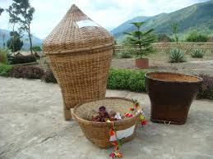

Fig2.5. Hrangkhol Basket

.

Chapter 2

Review of Literature

Some of the scholars already worked on socio- economic, cultural and historical aspect of the Hrangkhol people however no exhaustive linguistic work has been done on Hrangkhol language except C.A.Soppitt’s An outline Grammar of the Rangkhol- Lushai Language and Comparison of Lushai with Other Dialects which briefly discusses some of the issues of sound structure of the same.Besides,the available literature on this language is RamdinaLalsim’s Tribes of N.C.Hills,Assam which mainly discusses about the socio –cultural aspects of the Hrangkhol people.
As per by the (UNESCO) Hrangkhol language has been marked as an Endangered language since 2009,as Hrangkhol language has not much documented
So,as the work carried out on this Pronoun in Hrangkhol,there is an abundance of recent work as well as the lot of new typing and spelling was done here.For more information to described there was not much books issues on Hrangkhol Grammar so i have gone through the small books on ‘Hrangkhol namchongairchunalekhabu’ by Trisha Borgohain which was published in the year 2017 in the month of September it is the only recent books,and also from the books (2006) A Hand book of Hrangkhol Customary Practices:
The scope of Hrangkhol grammar work is vey vast and high chapter as it is sub – fields and it may not be possible to cover each and every one of them in a single paper or thesis in details.The upcoming scholars should grab this opportunity and used it properly so that more productive work is done which contributes to the Hrangkhol’s rich linguistic heritage.

Chapter 3

Objectives and Methodology
The main purpose of this work is to present the various work on the Ponouns on Hrangkhol Language, which i have discussed in my research work. Hrangkhol are mainly in Northeast India in the district of Dima Hasao and Karbi –Anglong in the state of Assam and Dholai district of Tripura and Manipur and they are mainly spoken in this three state in India.the total population of Hrangkhol are approximately of which it is lingua franca in the region.It has many dialect which co-related with the native speaker of Hmar,Biate and Sakachep.but my research will solely be confined to the Pronouns on Hrangkhol Language.
3.1 Objectives of the study
The main objectives of the study are as follows: 1. There is no gender distinctions of any kind in Hrangkhol Pronouns. 2.Thesingular,non-singular distinctions are found in Prounouns of Hrangkhol. 3.Prounouns in Hrangkhol are sub-class of Nouns by the criterion of person i.e Prounouns can be used in all three persons whereas nouns always use in the third person.
3.1.1 Data
The study of the analysis is based on morphological processes through a linguistic point of view. Being a native speaker of Hrangkhol, data has been collected from two main sources. They are:
3.1.2 Primary data
As being a native speaker of Hrangkhol, data has been collected through self-information sources. Here, I have provided the necessary data for this study by acting as an information. I have also collected data from persons like my parents, teachers, friends, relatives and older people and so on who speak the same variety this has helped me to run a cross check on my own data.
3.1.3 Secondary data
Most of the other required information has been collected from secondary sources. Data has been collected from existing literature in the form of books, journals, e-books, thesis and so on. Furthermore from the internet, social media has also been put to use in order to for a possible hypothesis as to explain the reason behind certain causes which are seen in the Pronouns.

Chapeter-4

Pronouns in Hrangkhol
4.1 An overview
Hrangkhol is one of the endangered Tibeto –Burman languages of Northeast India (UNESCO,2009) Kuki –Chin sub –group of the Tibeto –Burman languages family (Grieson –Konow,1903) and it is mainly spoken in DimaHasao and Karbi –Anglong districts of Assam and Dholai of Tripura and Manipur state.Hrangkhol is well known for their identity,indigenous knowledge systems, cultural ethnics,ritual practices and oral literatures
4.2 Pronouns
Pronouns in Hrangkhol are sub-class of nouns nevertheless,they are distinguished from the nouns by the criterion of person i.e pronouns can be used in all three persons where as nouns always use in the three persons in Hrangkhol distinguish singular non – singular distinctions but they do not show gender distinctions.The pronouns in the language may be categorised in the following types:
Personal pronouns Demonstrative pronouns Interrogative pronouns Possesive pronouns Reflexive pronouns.
4.2.1. PERSONAL PRONOUN
Generally,Personal pronouns of Hrangkhol can be categorised in three persons as shown in the table below.
 | Singular | Plural
1st person | kei ‘I’ | kǝi –ni ‘we’
2nd person | naŋ‘you’ | naŋ-ni ‘you’
3rd person | ǝma ‘he/she | an-ni ‘they’

Like many other kuki-Chin languages,the inclusive-exclusive distinction in Personal pronouns is found only in the case of first person plural such as ei –ni ‘we’(inclusive)vskei-ni ‘we’(exclusive)
Naŋtuk keini k^{h}uasuŋ fe kinti
tomorrow we village go 3PL FUT (exclusive)
Tomorrow we will go to village.

ei -nihai -hi mihriam viŋ
we PL human being-all (inclusive).
“We are all human being.”
4.2.2.Demonstrative Pronouns
As like English, Hrangkhol language also has four Demonstrative pronouns they are as below:
hi – ‘this’
hi – hai ‘these’

so – so ‘that’
so – hai ‘those’

hi kolom
this pen
“This pen”
hi – haikolom
these pen
“These pens”
so –so kel
that goat
“That goat”
so-hai inn
those house
“those houses”
4.2.3 Interrogative Pronouns
Hrangkhol in Interrogative pronoun is k^{h}oᶇ ‘where’.However,the rest of the interrogative pronoun root mo by attaching the prefixes i-,tu-,tuta-,tika-.It is noticed that the interrogative root is mo’Wh’
i-mo | what
tumo | Who
tika- mo | When
tuta-mo | Whose

4.2.4Possessive Pronouns
Possessive prounoun in Hrangkhol are formed by the pronominal prefixes
kǝima- ‘ my’
kǝi-ni ‘our’
naŋ – ma ‘your’
naŋ – ni ‘yours’
4.2.5. Reflexive Pronouns
Reflexive prounoun in Hrangkhol is formed by suffixing – biɳ to the possessive pronoun as shown below.
ki – biɳ | myself
ni –biɳ | yourself
an – biɳ | themselves
a – biɳ | himself/herself

‘ki biɳ in cɑr kir sᴕp
I myself car PST wasʰəd
“I washed car myself”

‘ Ni biɳin avuan sukul ni fə mo’
Yourself today school you go Cont.
“You are going to school yourself today”

CONCLUSION
The present work shows the structural description of Hrangkhol language of Tibeto-Burman language family. Hrangkhol is the native of Assam in the district of Dima Hasao and Karbi- Anglong, Tripura district of Dholai and Manipur state,and in some part of Barak valley. Hrangkhol script can be found in the present district of Dima Hasao of Haflong and so on . Hrangkhol falls under the Tibeto-Burman family it is also known as Kuki – Chin group.
.
Prounoun in Hrangkhol the personal prounouns can be categorised in three person viz.kei,1st SG, nan,2nd SG, ama 3rd SG.Like many other Kuki – Chin Languages the inclusive –exclusive distinction is there in personal pronouns is found only in the case of first person plural viz. eini (inclusive) and keini (exclusive).Interesting part is that, the Nominative case in Hrangkhol is marked by the marker –in, Hrangkhol there is no distinct marker for accusative,and dative. Like accusative, the dative is realized by the marker-kha.
To conclude Pronouns and types of pronouns can make up a single thesis if they worked on details covering every phonological, morphological, syntactic and semantic aspect of the resultant of that particular process and grammar. Research in this field is left open and given the proper encouragement and opportunity, I’d be very keen and graceful to take it up and contribute to my community as the field work of research in Hrangkhol.

BIBLIOGRAPHY

1.Dixon,R.M.W.(2012).Basic Linguistics Theory,Vol.3,United States: Oxford University Press.

2.Graham.Thurgood and Lapolla, Randy J.(2003) The Sino –Tibetan Languages. London :Routledge.

3.http./www.hrangkhol.in/en/background –Hrangkhol.

4.Lalsim, Ramdina.(2005)Tribes of N.C. Hills.Haflong.N.C.Hills Autonomous Counsil.

5.Soppit,C.A (2007).A Short Account of The Kuki –Lushai Tribes on The North East Frontier with An Outline Grammer of The Rangkhol- Kuki – Lushai Language. Kolkata:Kreativmin.

